

Assessment Cover Sheet
Assessment Title
IT8416-Project (Group)
Assessment Type
Uncontrolled
Group
Not must-pass

Due Date |  | 1st June 2026 | Course Code | IT8416
Course Title |  | Data Mining

Internal Moderator’s Name
Dr. Sayed ElKenawy

External Examiner’s Name
Dr. Mekala Soosay

Instructions:
- This cover sheet must be completed (section in blue below) and attached to your assessment before submission in hard copy/soft copy.
- The time allowed for this assessment is XXX minutes/hours/days.
- This assessment carries XXX marks distributed to a total of XXX questions assessing CILO X and CILO
X.
- The materials allowed for use in this assessment are XXX, XXX, and XXX.
- The use of generative AI tools is strictly prohibited.
- References consulted (if any) must be properly acknowledged and cited.
- The assessment has a total of XXX pages.
1ST June 2026
Lecturer’s Name
Programme Title
Programme Code
Learner Name
Date Submitted
Learner ID

By submiting this assessment for marking, I affirm that this assessment is my own
Do not write beyond this line. For assessor use
Comments:
Maks Obtained
Marking Date
Ancy Cheriyaan
Assessor’s Name
Learner Signature


Section No. | 001 | Group No. | 01

No. | Student Name | Student ID
1 | Ansa Shakeel | 202304076
2 | Dana Aljowder | 202304033
3 | Bayan Alalawi | 202304031
4 | Adnan Husain | 202300509
5 | Yusuf Abdulrahim | 202302530

Table of Contents
Task 1 - Problem Statement Formulation and definition 3
Business Goal 3
Problem Statement / Project Definition 4
Motivation 4
Objectives 4
Expected Results 4
Task 2 - Selection of an Appropriate Data Set (Data Collection) 4
Source of Dataset 5
Link to our dataset 5
Dataset Justification 5
Initial Data visualizations 5
Task 3 -Preparation and Pre-processing of Selected Data 6
Create Binary Churn Column 7
Remove irrelevant Columns 9
Handling Missing Values 11
Encode categorial columns 14
Normalization 14
Apply PCA 15
Cumulative PCA Variance 16
Data Visualization 17
Task 4 - Building Data Mining Models 18
Problem type and technique selection 18
Splitting the Dataset 18
Model 1: Decision Tree Classifier 20
Model 2: Random Forest Classifier 22
Model 3: Ensemble Voting Classifier 23
Task 5 - Evaluating Data Mining Models 25
Metrics Justification 25
Model 1 Evaluation – Decision Tree 26
Model 2 Evaluation – Random Forest 26
Model 3 Evaluation – Ensemble (Vote) 26
Confusion Matrix 27
Task 6 – Inferences, Recommendation and Reflection 28

Task 1 - Problem Statement Formulation and definition

Business Goal
One of the most competitive industries in the world is telecoms, where businesses struggle to keep current customers while making big investments to attract new ones. Customer churn is a major business issue that directly affects revenue. It is a situation where subscribers stop using their services and switch to competitors. Churn prediction is a high-value data mining application because, according to company estimates, getting a new client is more expensive than keeping an existing one.

Problem Statement / Project Definition
This project aims to use data mining techniques to analyze the telecom customer data and build predictive models to identify customers who are prone to customer churn, so that effective customer retention actions are performed. Problem statement is that as given a dataset of 7,043 telecom customers that includes profile data, service usage patterns, billing information, and past churn behavior, can we create a correct classification model that predicts whether a specific customer is likely to churn? This would allow the telecom provider to implement targeted, profitable methods for maintaining clients and lower the overall churn rate.

Motivation
Companies in telecommunication lose money every time a customer leaves the company for a competitor. Churn is a major concern since most telecommunication firms make more money by keeping customers than replacing them. Telecommunication companies are often interested in learning the particular customer behavior that indicates customer churn. The types of customers can be classified by service usage, type of contract, method of payment, service charge, and customer support service provided by the company. Techniques from Data Mining, which have led to a range of new data-intensive research avenues, can be applied to predict which customers are at risk of churn, the companies can start some retention efforts in the form of giving discounts to some of their valuable customers, improving quality of their service or hiring and improving the service of Customer support.

Objectives
Understand what are the variables that are correlated with the customers who left, stayed, and who were added recently through customer data mining.
Identify which among those correlated variables are responsible for the churn.
Build a data mining model which predicts if the customers are more likely to churn.
Provide a framework through data mining for telecom companies to use on the customer data so that they improve retention rate.

Expected Results

The project will culminate in identifying major reasons why customers might leave such as type of contract, monthly charges, tenure, Internet Service, Payment Method, Customer support service. Moreover, it will yield a model that classifies customers into either of the categories 'Likely to Stay' or 'Likely to Churn'. The ultimate results of the project will equip the telecom company with a clear understanding of customer behavior, timely detection of high-risk customers, and consequently improved decision-making for customer satisfaction and retention.

Task 2 - Selection of an Appropriate Data Set (Data Collection)

Source of Dataset
We used the Telecom Customer Churn Dataset from Kaggle because we thought it would be a good dataset to work with for our project, since it is trying to predict whether the customer will churn/leave your business. It has attributes of customer demographics, what type of plan they are using, contract duration, payment type, how they are paying, what internet service provider they use and customer charges to better get an understanding of churning customers and patterns in churn behavior.

Link to our dataset

https://www.kaggle.com/datasets/shilongzhuang/telecom-customer-churn-by-maven-analytics

Dataset Justification

Our project requirements are at least 250 instances and 8 features: the data set has 7043 customers and 21 features. The attribute of the dataset that is being predicted is called Churn, and this attribute indicates if a customer churned or stayed with the company.

Some features have qualitative attributes, while others have quantitative. Qualitative features are gender, Partner, Dependents, InternetService, Contract, PaymentMethod and Churn. The quantitative features are tenure, Monthly Charges and Total Charges. The SeniorCitizen attribute is quantitative, but it describes the Customer's life stage of being a senior or not.

Within the TotalCharges column, there were a few missing/blank values. This is usually the case with new customers who have only been using the internet for a short period of time. This issue will be addressed when performing feature engineering. The customerID attribute is not very useful because it does a specific thing - to identify customers - but it is not useful in predicting who leaves the company.

On exploring the data, we found that churn was not evenly distributed, that is, the majority of customers churned out, and a few customers churned out. This means that the data set has a slight imbalance. It looks like a lot of customers churn if they are on a month-to-month contract and the higher their monthly charges, they seem to be at a greater risk of churning, and this risk also increases as their tenure is smaller. Given all the above, this dataset appears to be the best candidate as it is the largest, it also meets the problem we are looking to solve and can be applied to classification and predictive analysis as well.

Initial Data visualizations

Some visualizations before the data preprocessing are shown below.
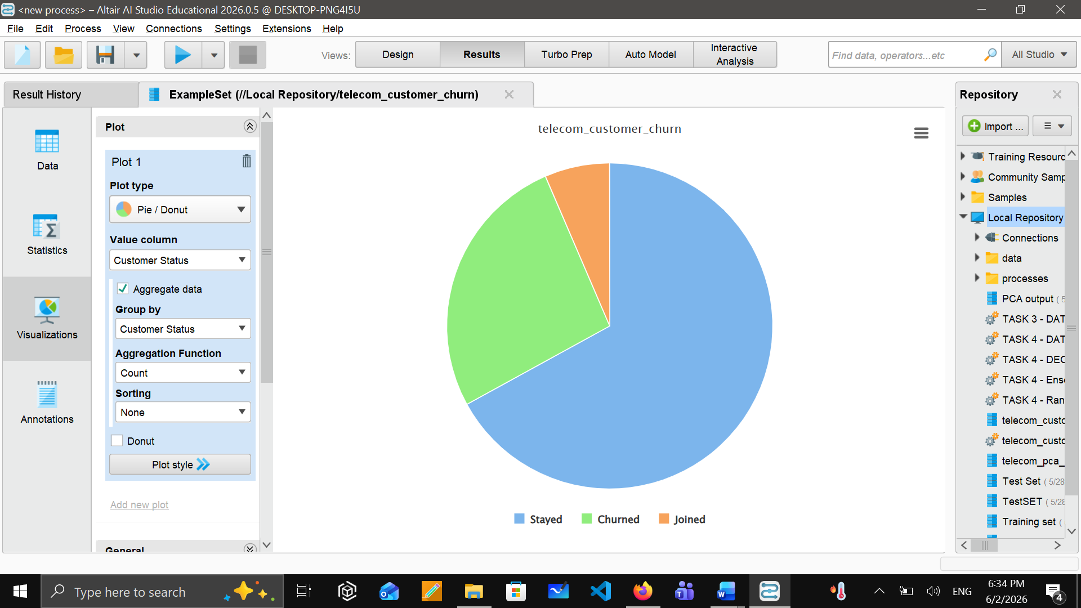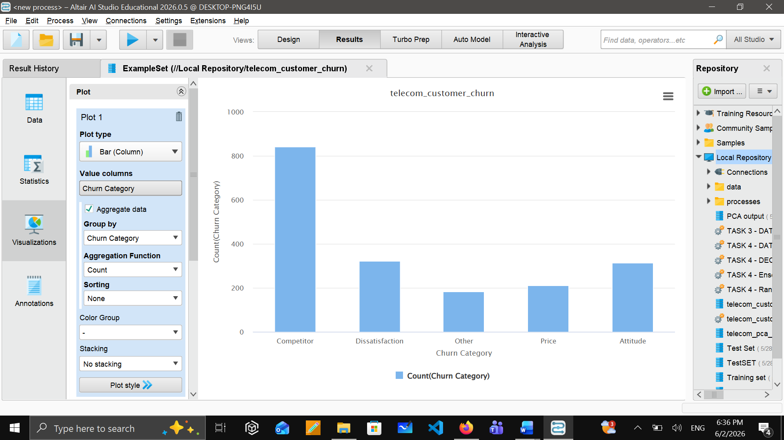
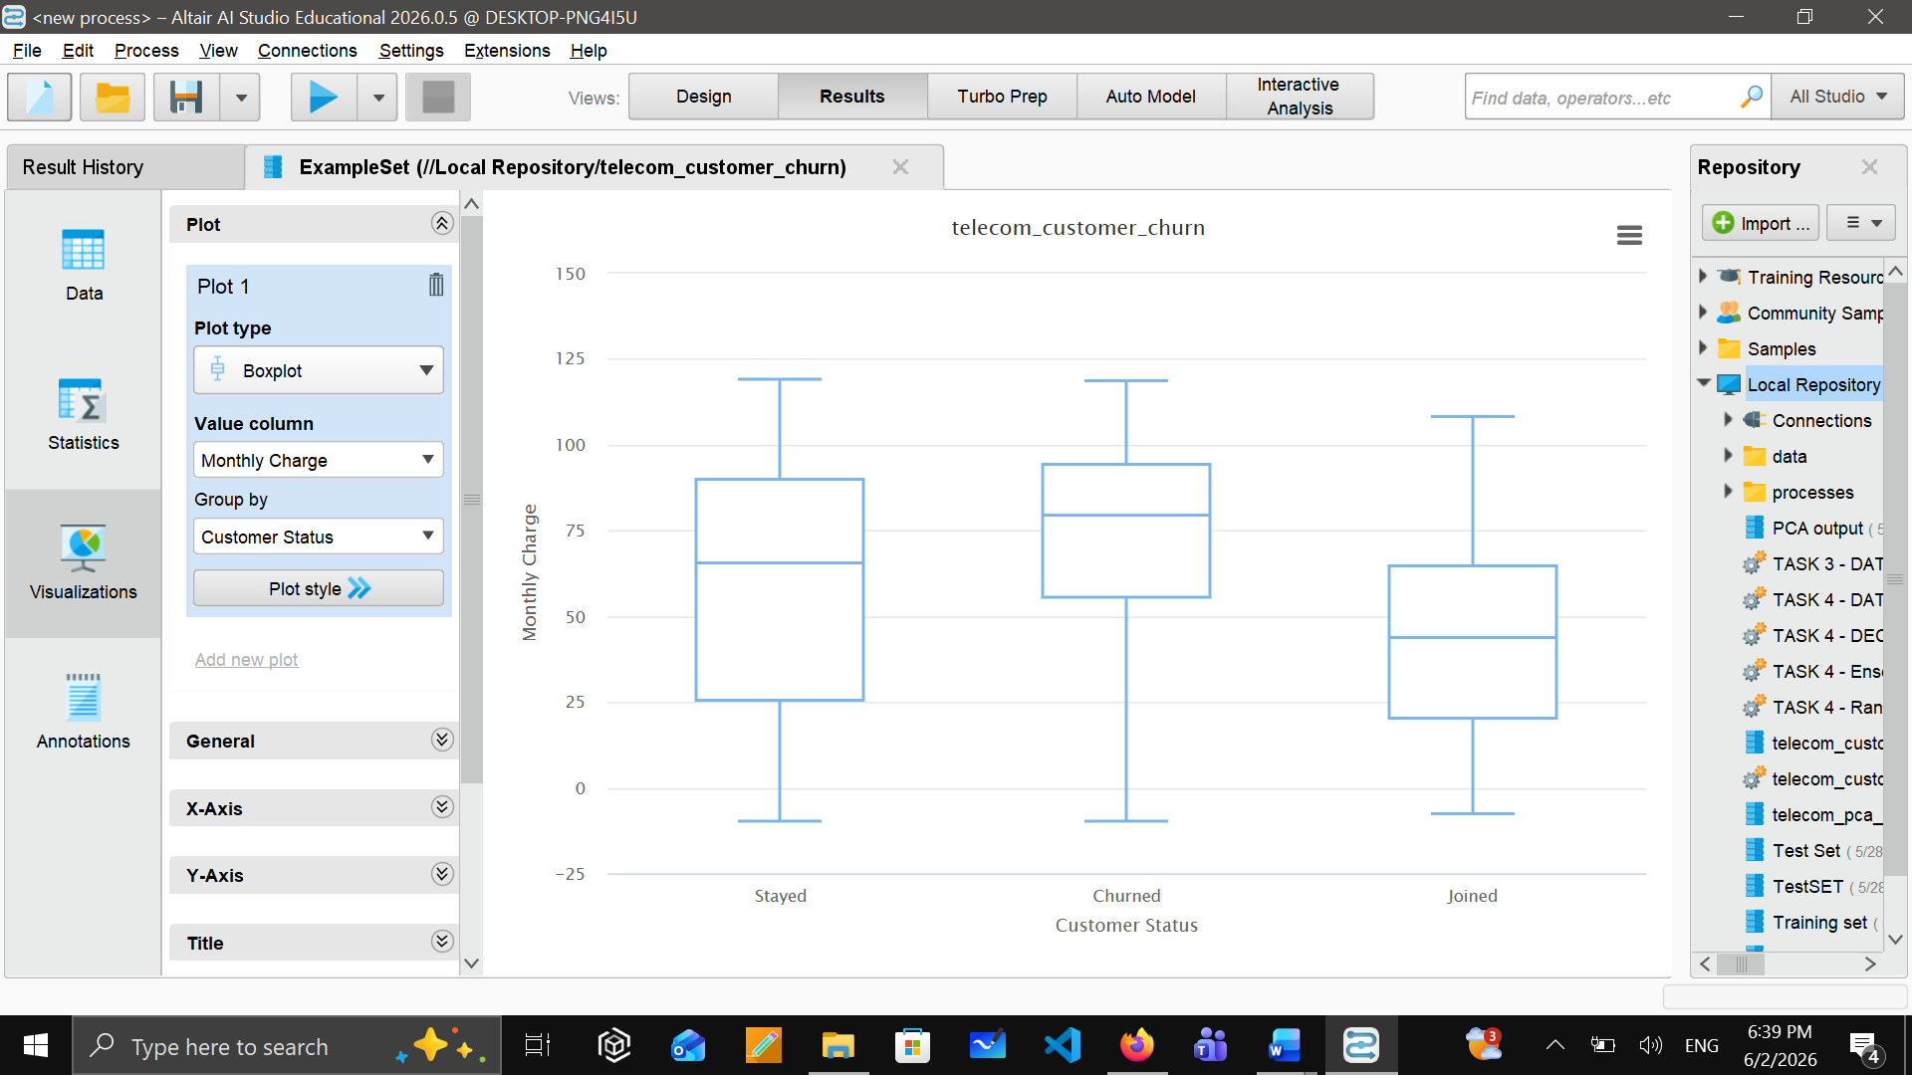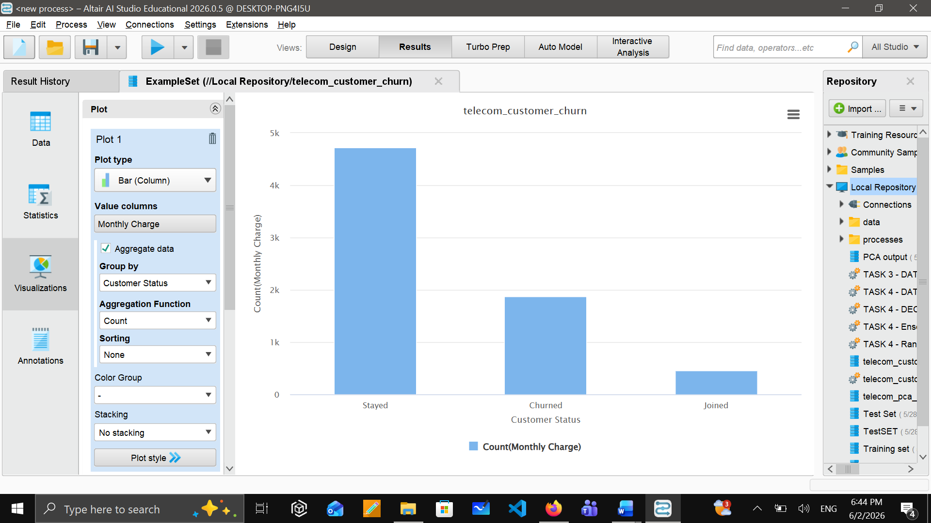

Task 3 -Preparation and Pre-processing of Selected Data

We took the Telecom Customer Churn dataset into Altair AI Studio (RapidMiner) to clean up and start our analysis. We had a total of 7,043 customer records and 38 attributes about each entry including their demographic info, services they use, billing details and their status as customers. Before we started cleaning and prepping the data to apply other processes, we looked at an overview of what kind of data existed in the dataset with RapidMiner’s Statistics & Data views to determine the basic structure of the data, types of data that exist within it and how the data is distributed.

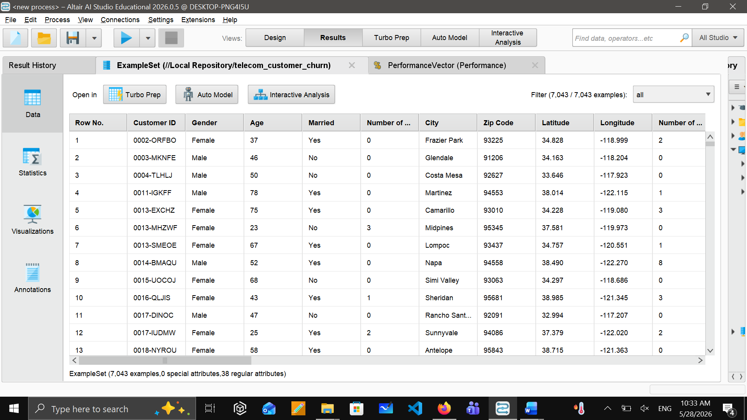
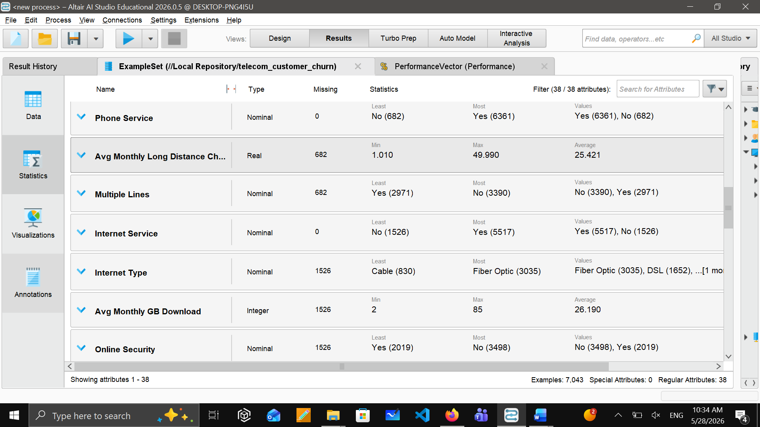

Create Binary Churn Column
Here, we need to tell AI studio that our main target is the column that is “Customer status: Churned”. To do this, we used the operator “Generate Attributes”. Within that operator, we wrote a formula which is “if([Customer Status] == "Churned", 1, 0)” and we name a new attribute as “Churn”. After that we used another operator “Set role” to set our targeted column(Churn) as a Label.

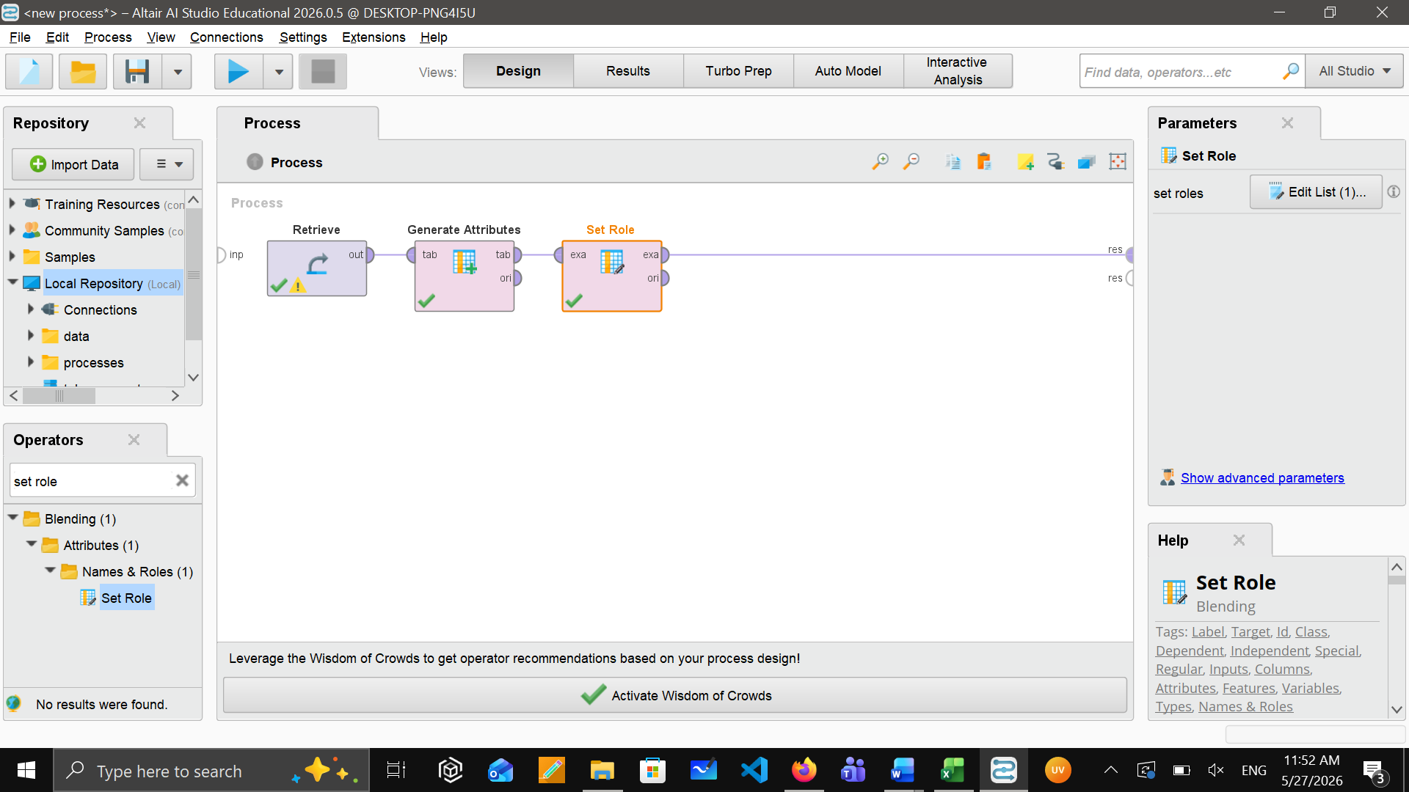
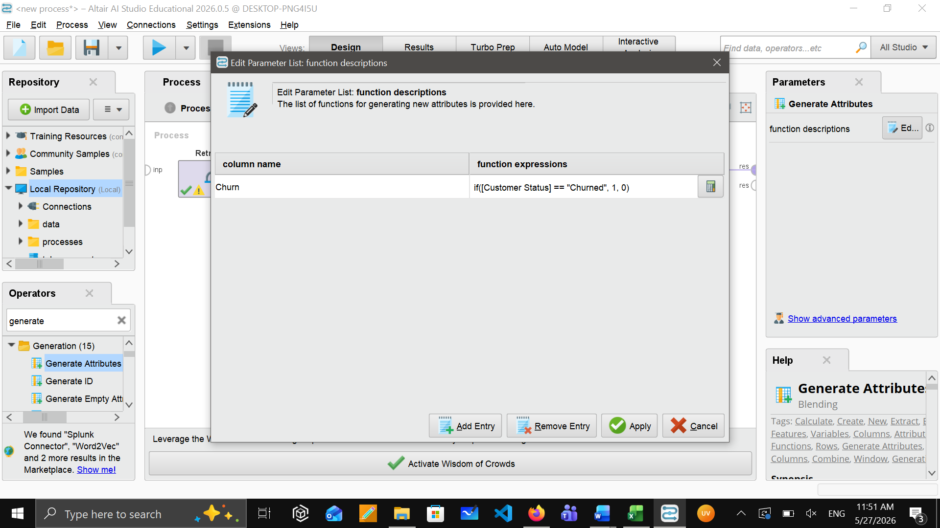
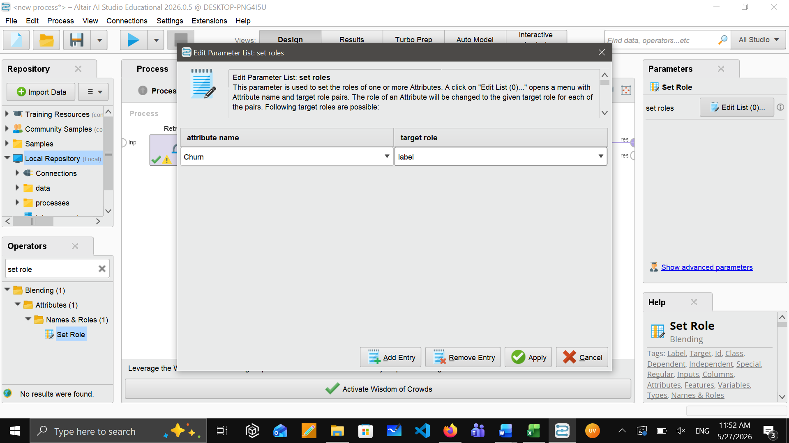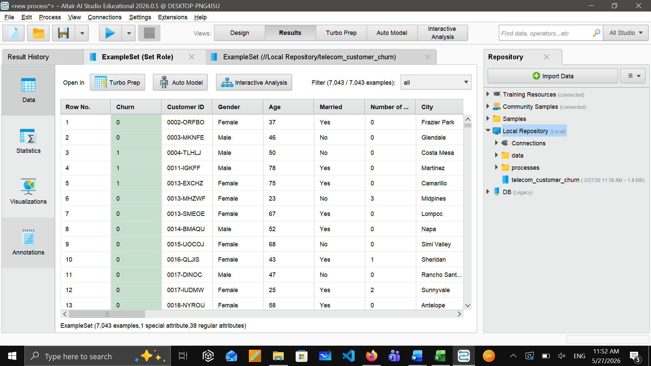

Remove irrelevant Columns
There are some columns in our data that are useless or cause data leakage, we will remove them to reduce our data, and we will keep only the important columns that will help us to make decisions. To do so, we used the “Select attribute” operator.
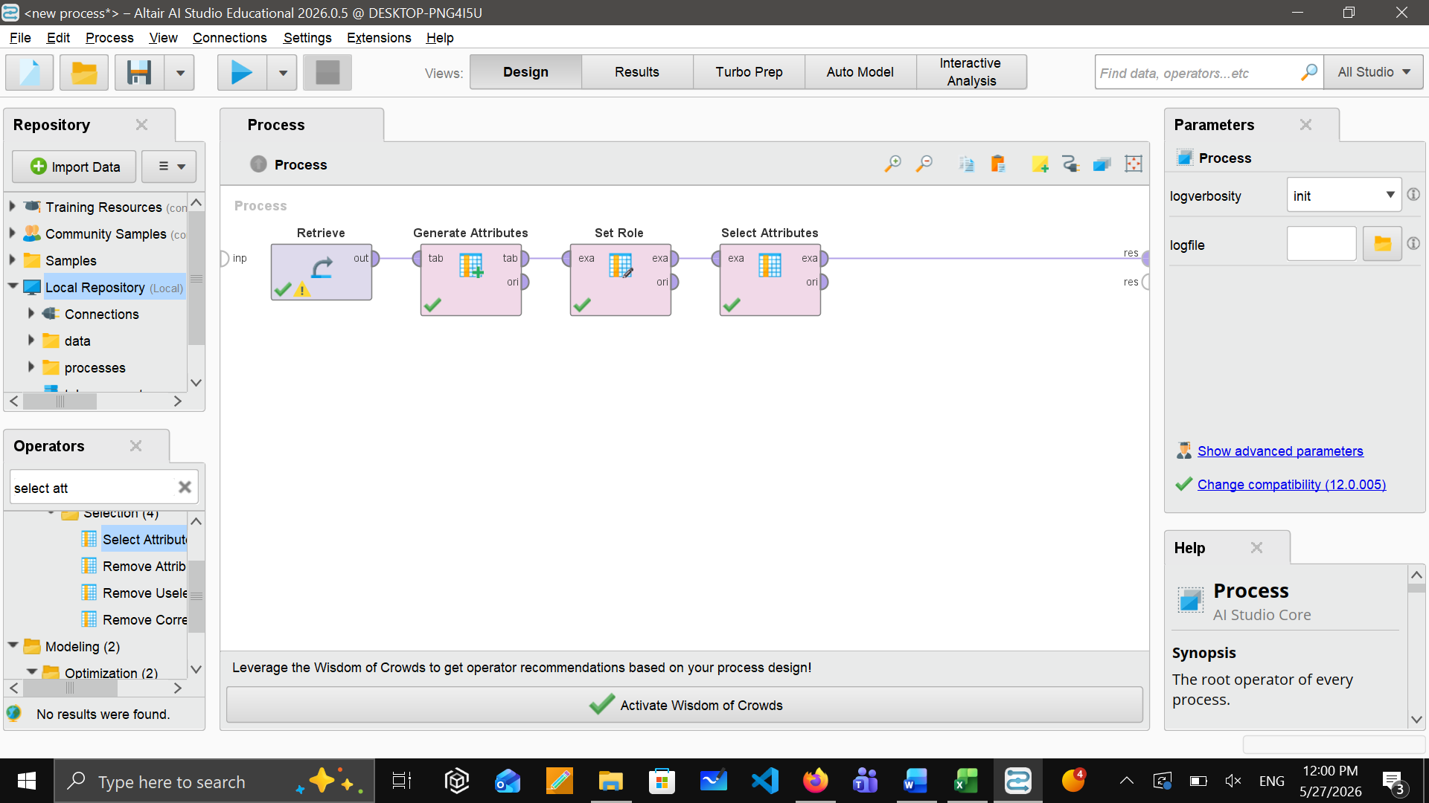

By using this, we removed few columns from our data which are as follows along with the reason:
- Customer ID (id can’t predict the value)
- Zip Code (not useful for prediction)
- Latitude & Longitude (not useful for churn)
- City (too many unique values)
- Churn Category (data leakage!)
- Churn Reason (data leakage!)
- Customer Status (we already created the Churn label from this)
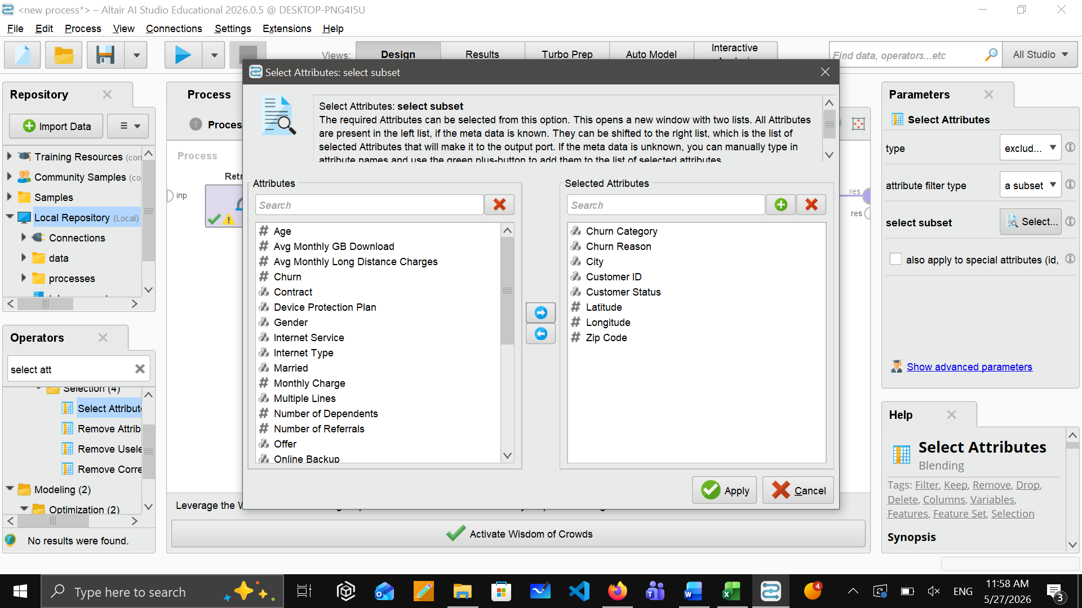

Handling Missing Values
To maintain the quality of our data to be at its maximum level all the time, the Replace Missing Values operator in RapidMiner was used to handle our missing values in our data set. After this process, we were able to proceed to the data preparation stage. Here, we did two types of handling missing values:
Missing values from categorial columns
Missing values from Numerical columns
From the categorial columns, we replace missing values for Offer, Internet Type, Online Security, Online Backup, Device Protection Plan, Premium Tech Support, Streaming TV, Streaming Movies, Streaming Music, Unlimited Data, Multiple Lines. And we replace them with a value “No service”. This means that the customer simply doesn’t have a service.
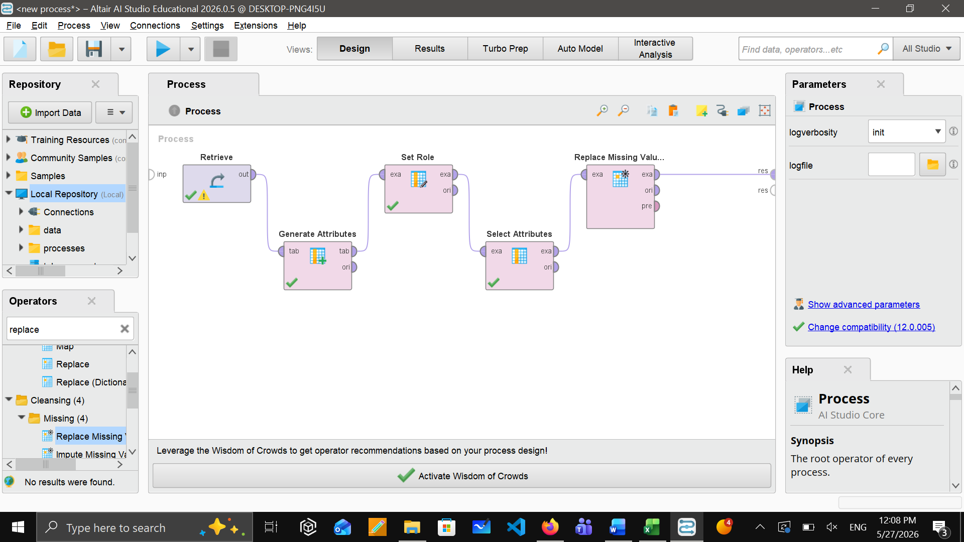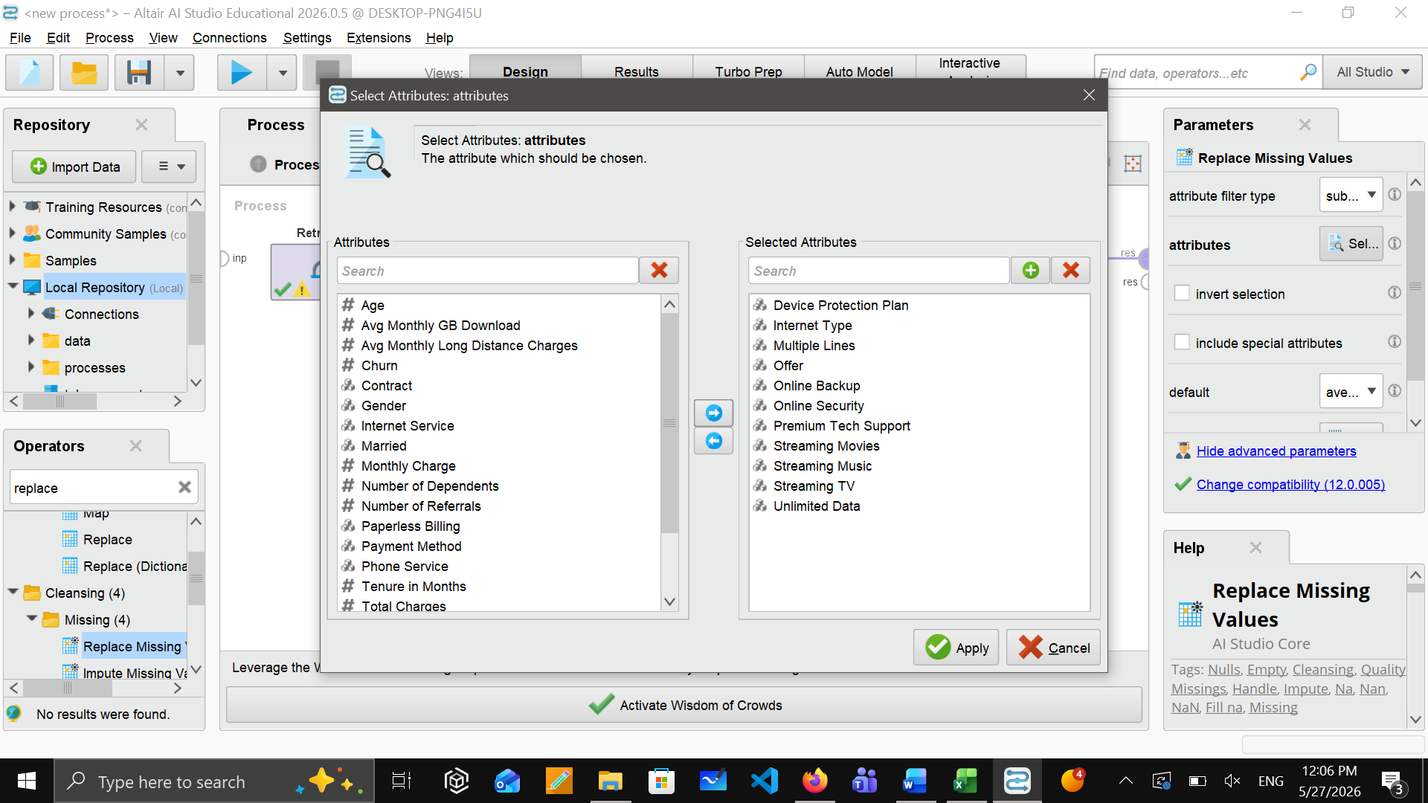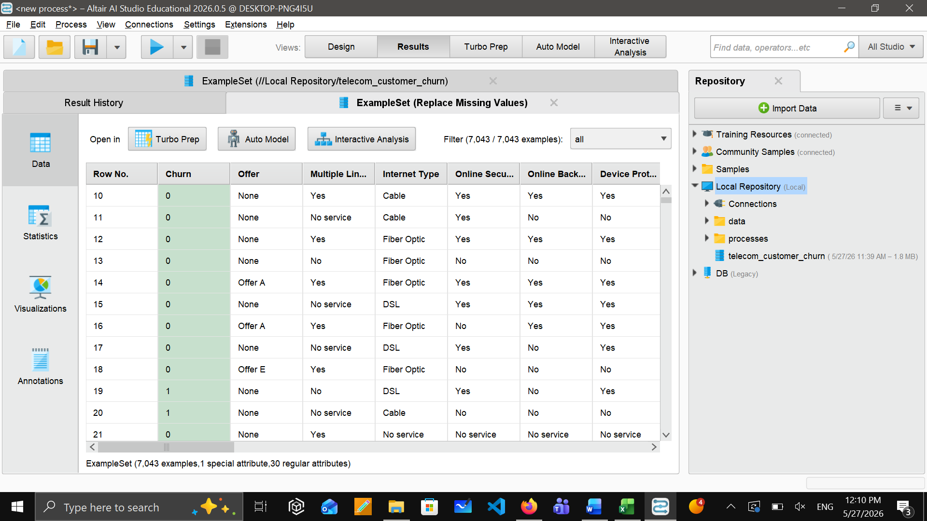

From the numerical columns, we replace missing values from vg Monthly Long-Distance Charges and Avg Monthly GB Download. And we replace them with average. It means that instead of deleting rows, it will fill them with a reasonable number.

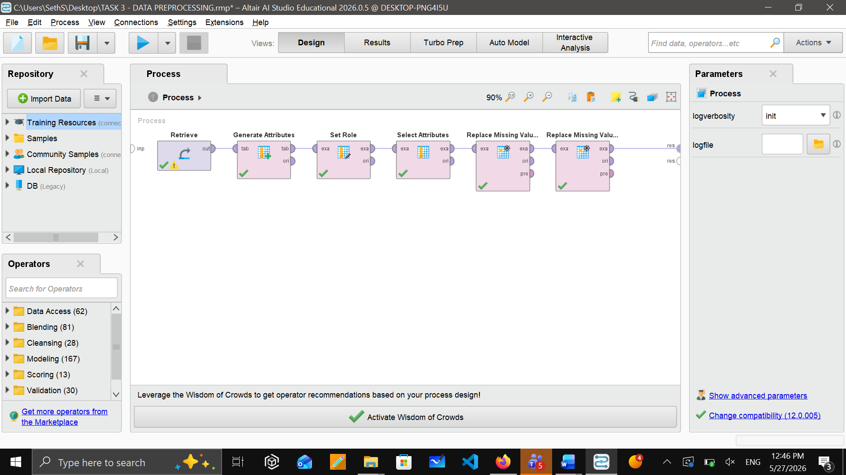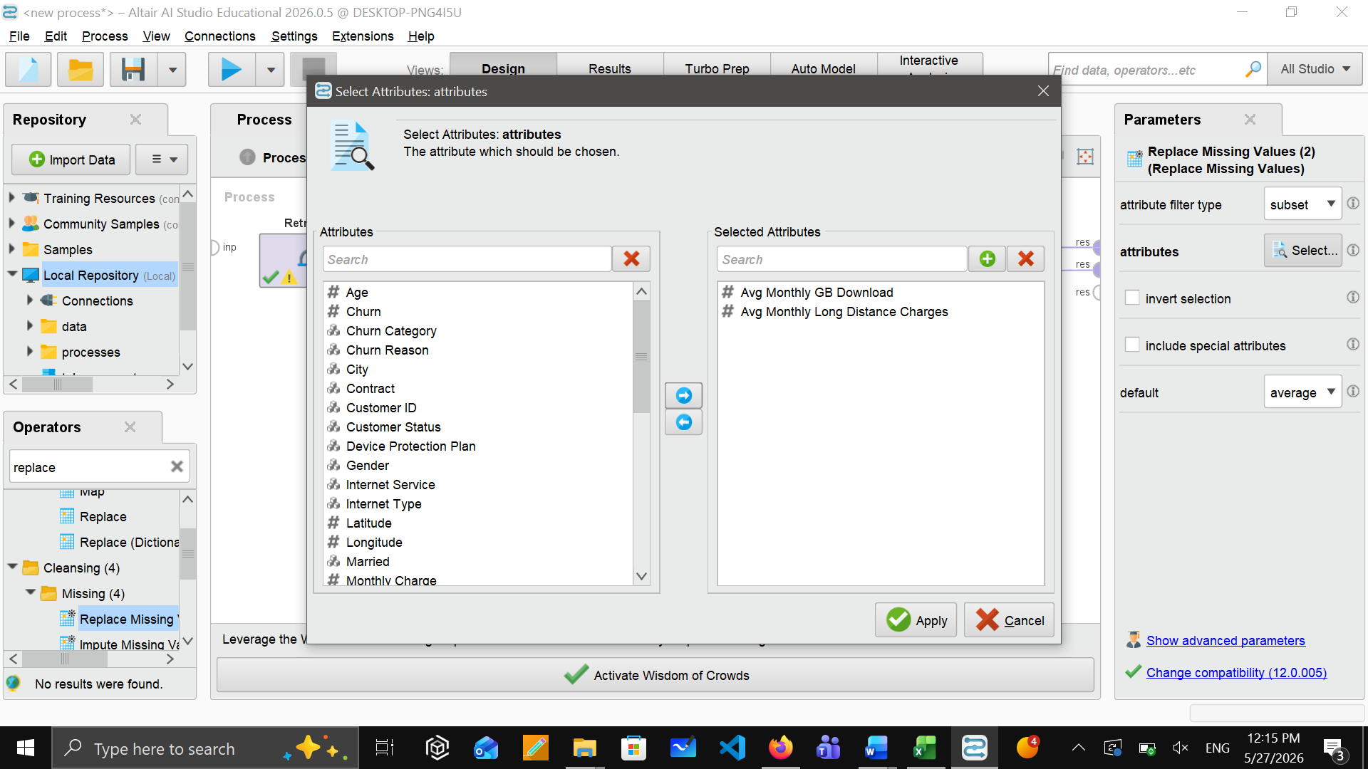

Encode categorial columns
Using the “Nominal to Numerical” operator, we converted the text columns into numbers so the model can read them. We selected all categorial columns and used the encoding method as “integer”. The columns that were affected are Gender, Married, Offer, Contract, Internet Type, Payment Method, and all Yes/No service columns.

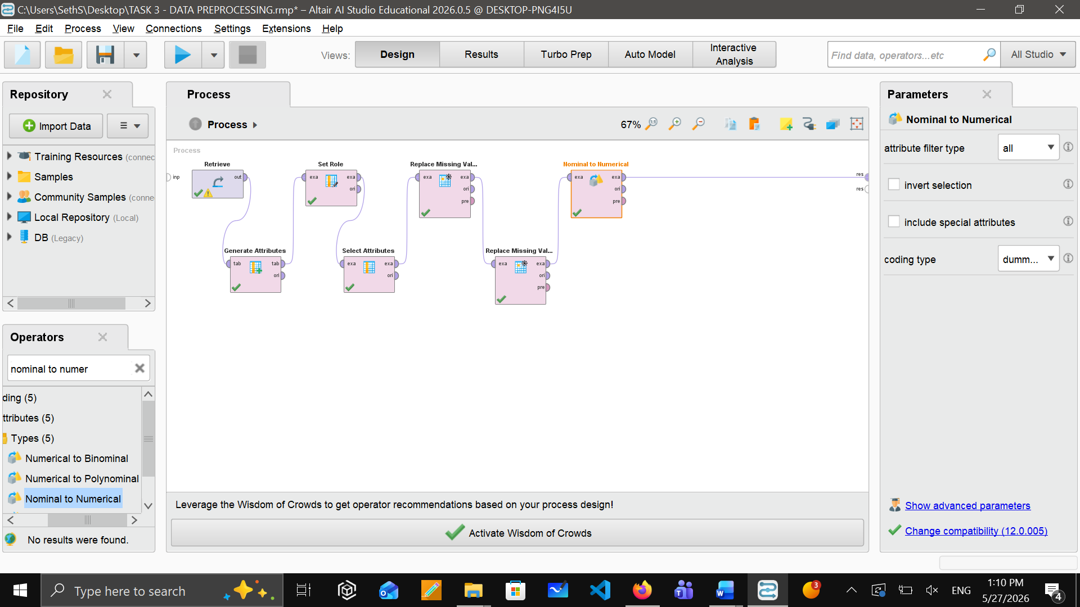

Normalization
After encoding, we used the operator “Normalize” to make all numbers on the same scale. We used the method “Standard scaler”. Mean will be 0 and standard deviation will be 1. This step is important because PCA will be affected by large and small numbers so it will apply to all numerical columns.

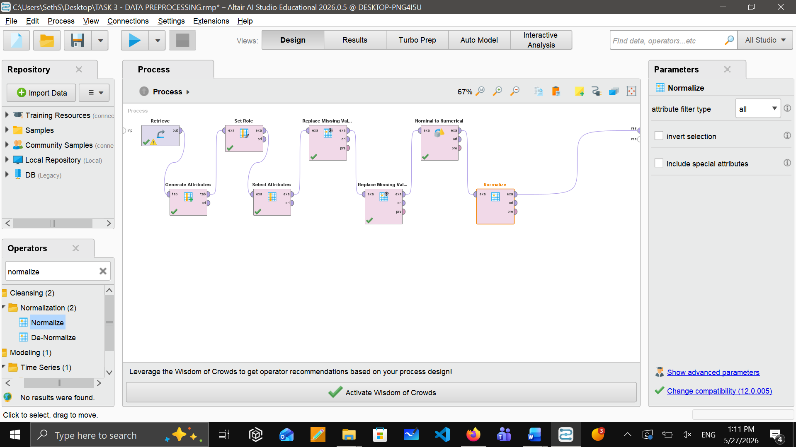
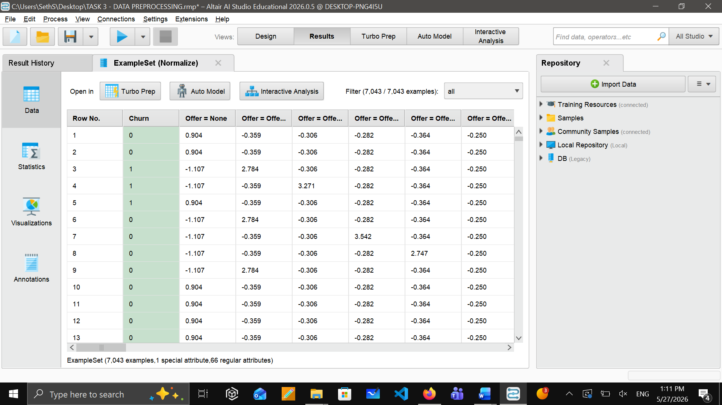

Apply PCA
Here, we used the operator “PCA” to reduce the dimensionality of data. We selected variance of 0.85 for PCA, meaning 85% of the total variance in the dataset is retained. We chose this to balance dimensionality reduction as well as to keep the important information. This reduced the data with 20 principal components while keeping the data sufficient for accurate churn analysis. This step of removing noise dimensions is also important to improve data modelling generalization.

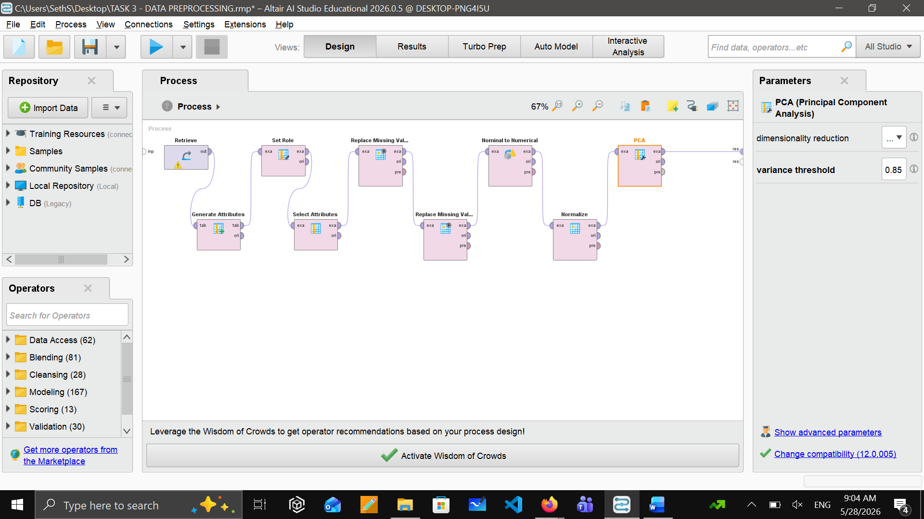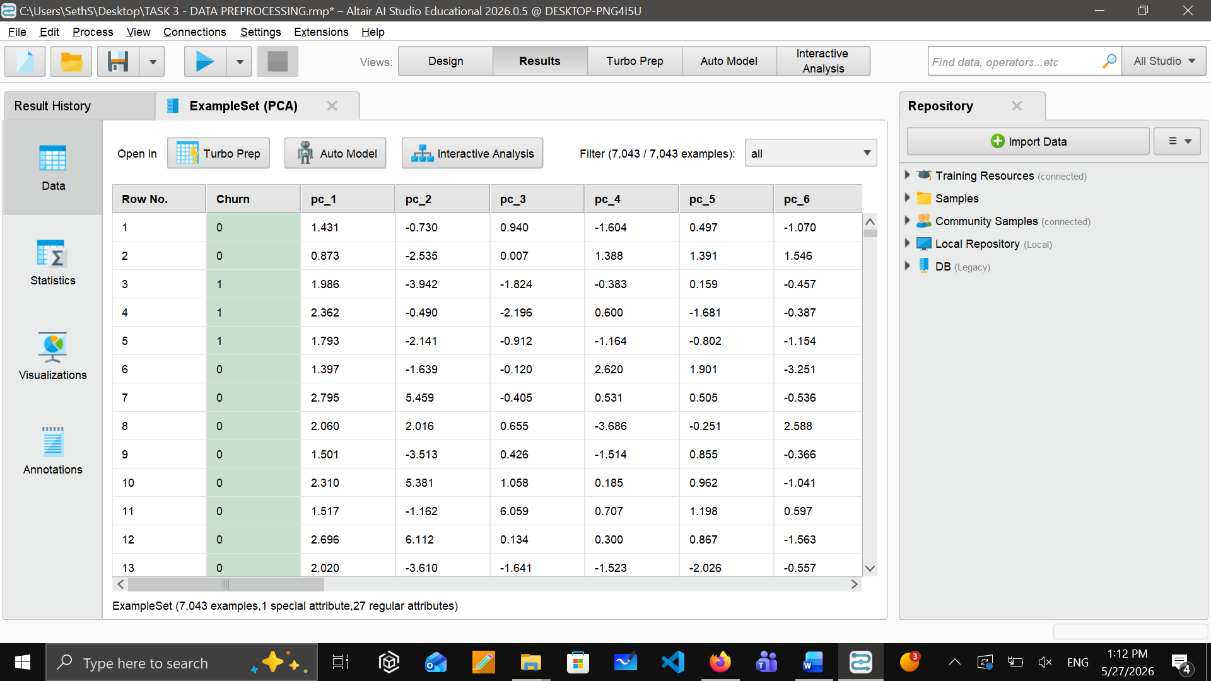

Cumulative PCA Variance

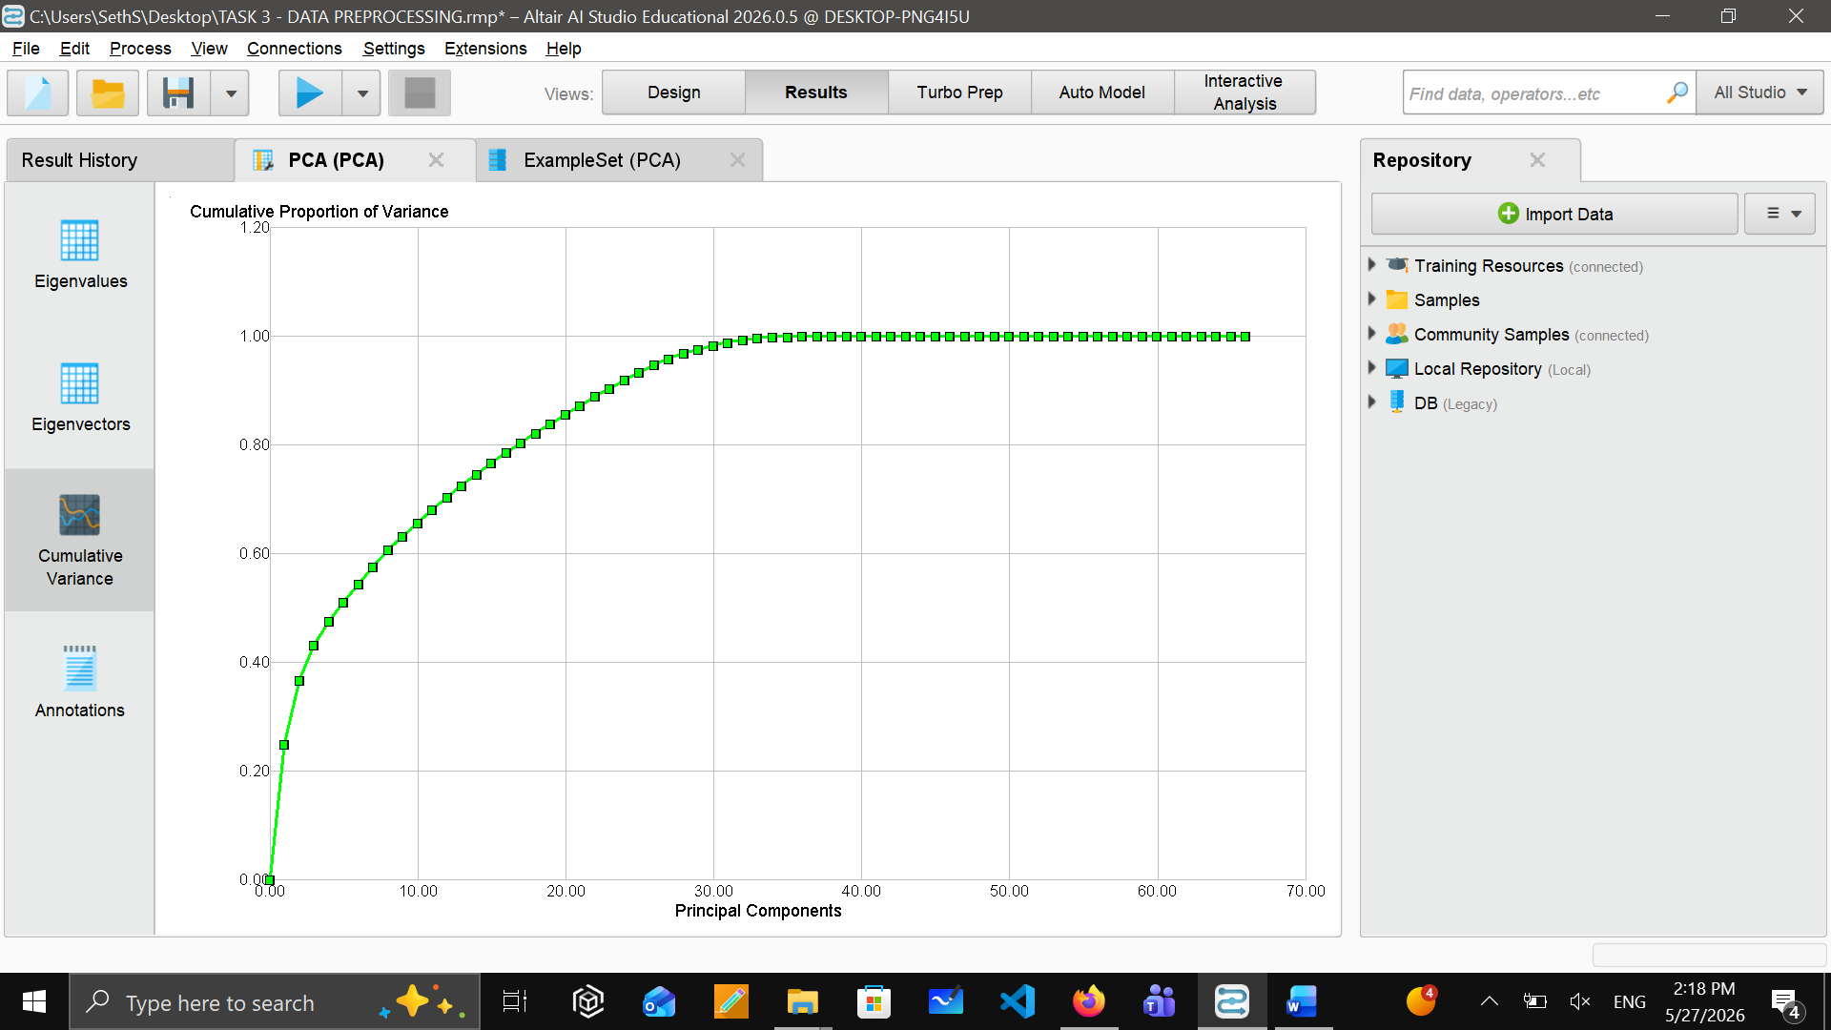

Data Visualization
With RapidMiner, we used a variety of visualization tools like Box Plots, Histograms, Pie Charts and Bar Charts to view our telecom customer churn dataset. By viewing this data through many different lenses, we were able to see how the data was distributed, proportionally how many customers are currently active/ inactive or churning per month; also, internet service usage trends etc. All of this gave us a much deeper understanding of the dataset prior to implementing the machine learning model.
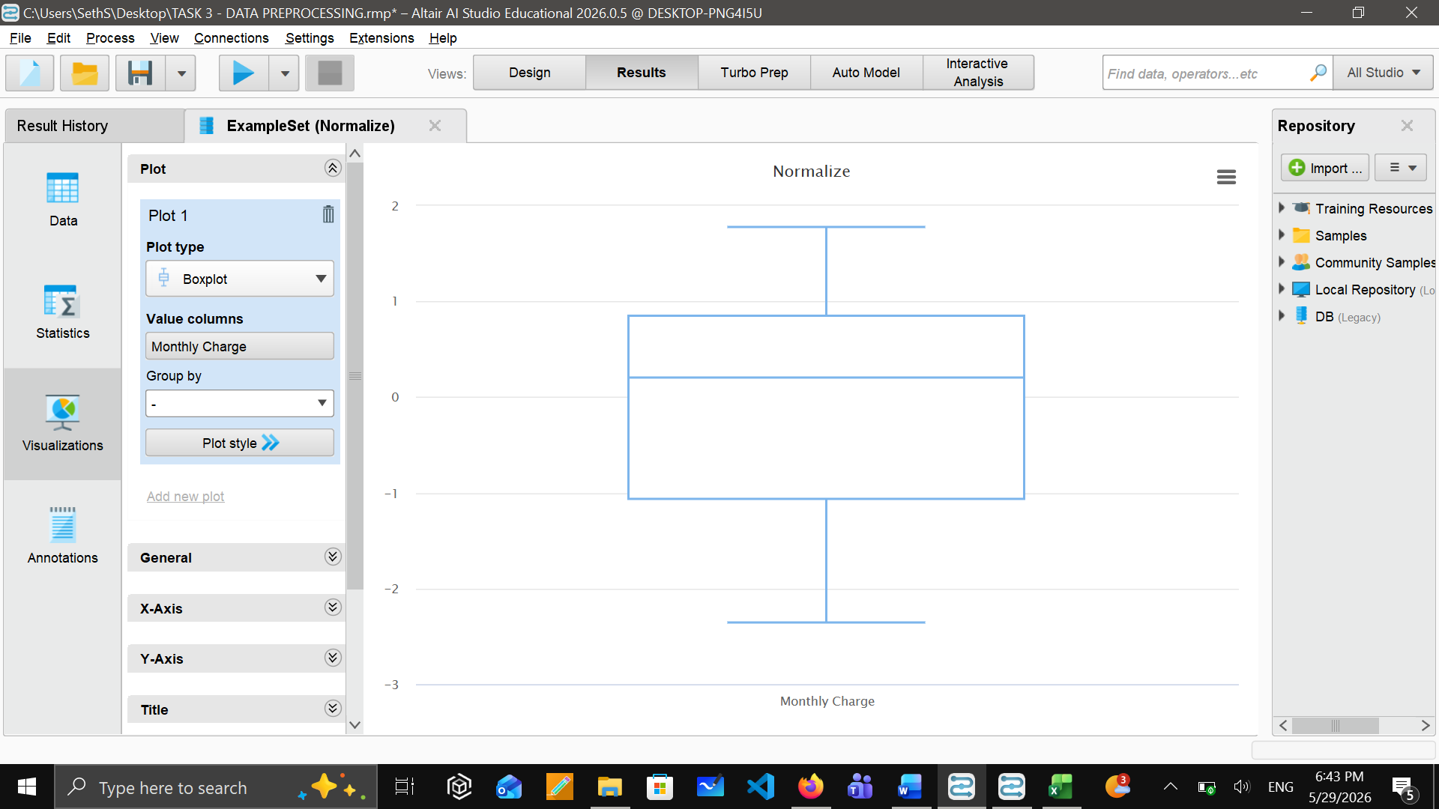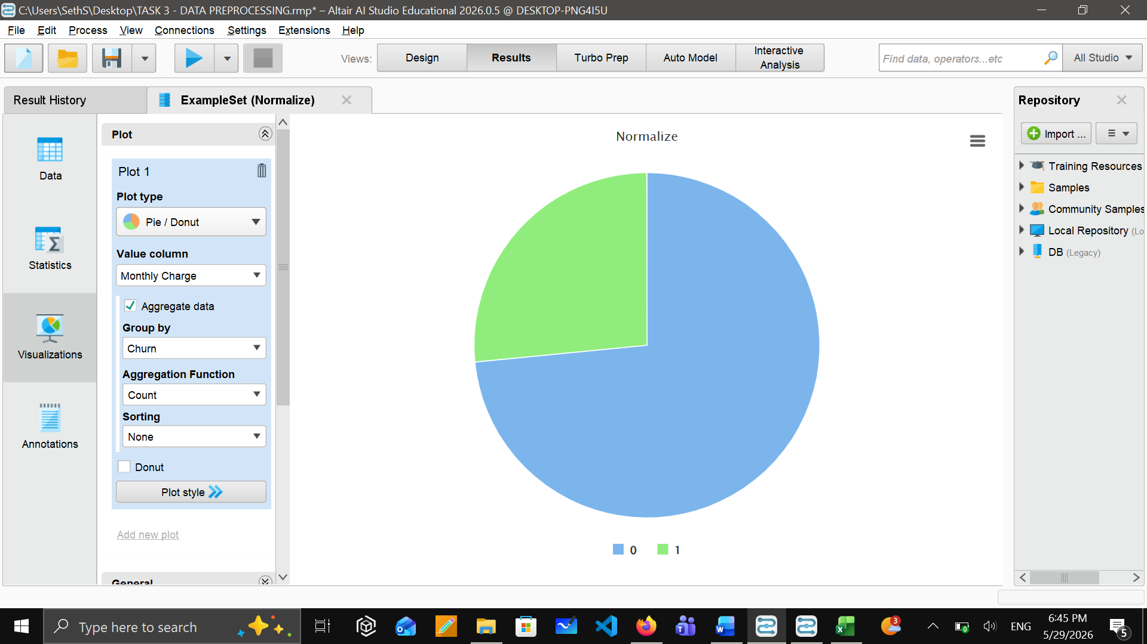

Before and After
Missing values before data preprocessing and zero missing missing values after preprocessing.
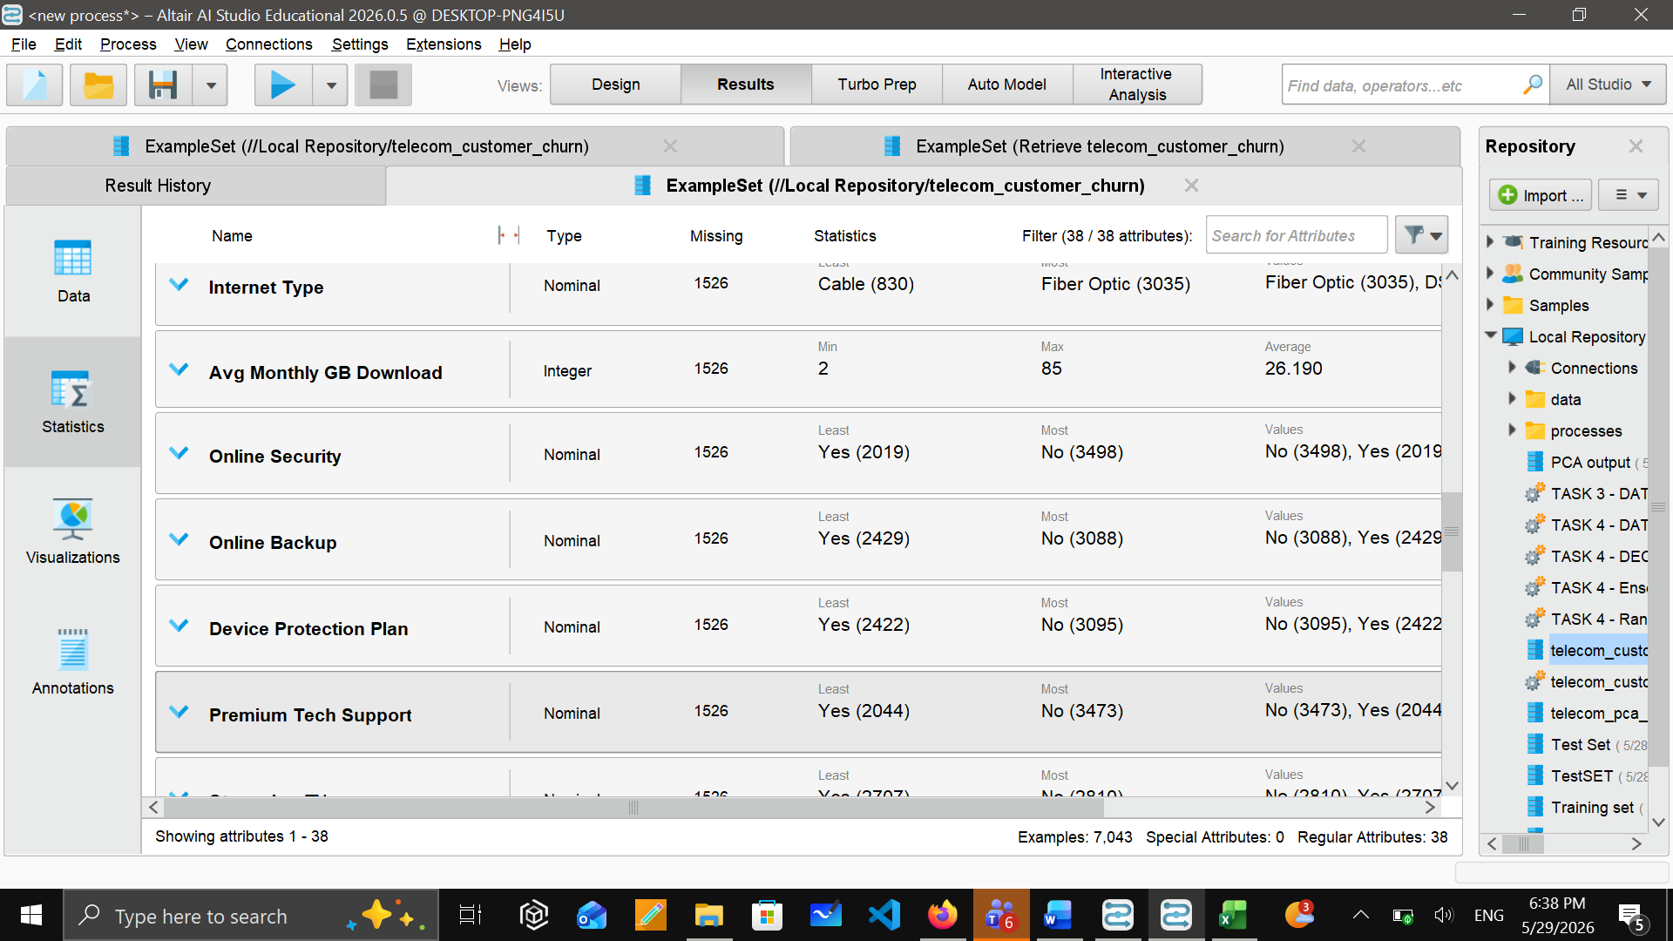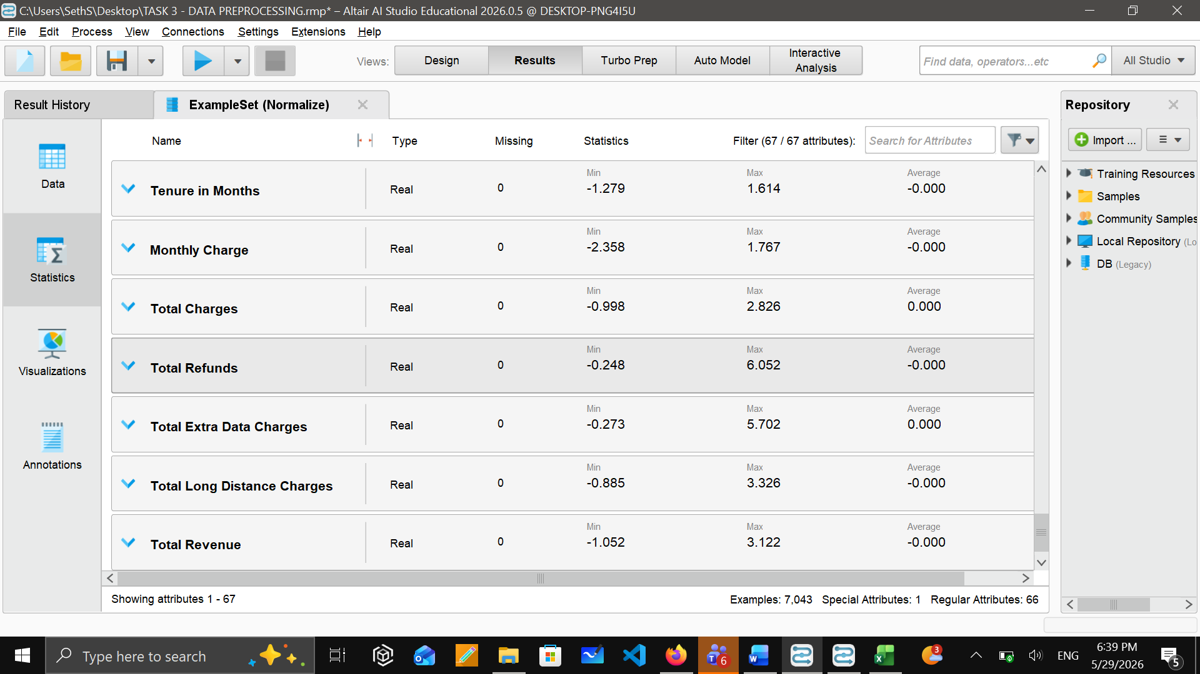

Histogram for monthly before and after the normalization. You will notice that the values changed from (20-120 range) to (-2 to +2 range).

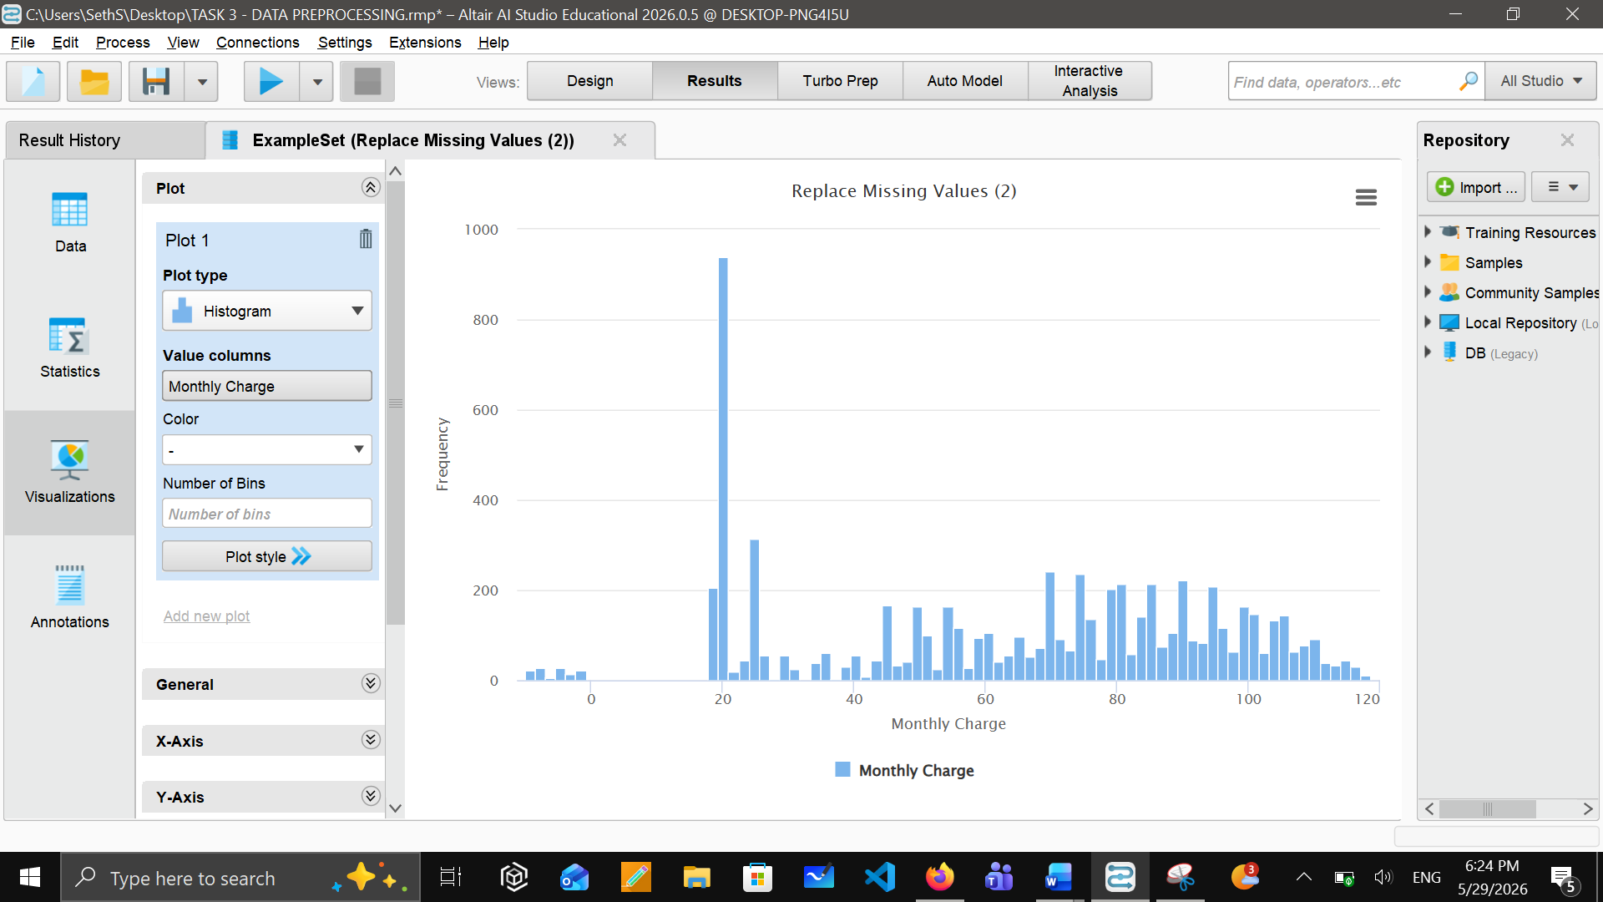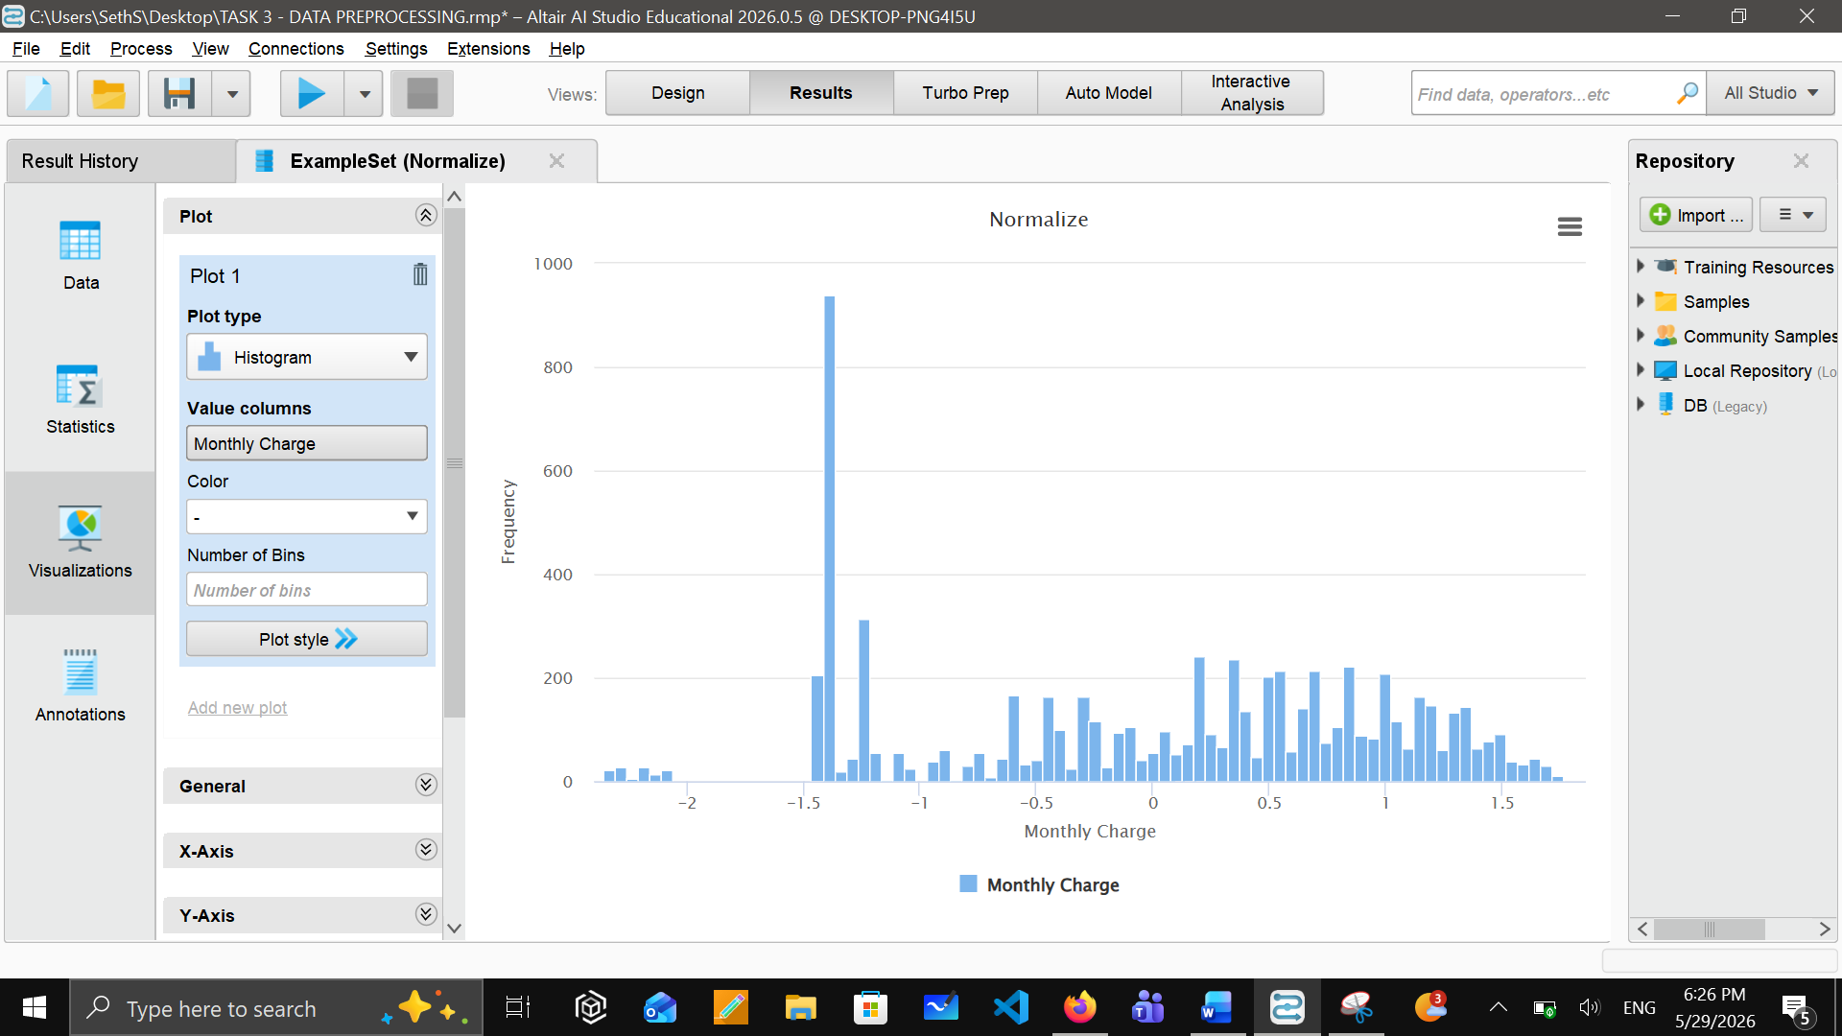

Task 4 - Building Data Mining Models

Problem type and technique selection
Based on our project objective, this is a supervised classification problem. As our target variables are Churned (1) and Stayed (0). Supervised technique will be appropriate for this because we have historical data from which the model can learn patterns and then apply those patterns to predict churning for the customers that are unseen. By having prepared data, we used a supervised technique, and we selected three models and built them:
- Model 1: Decision tree Classifier
- Model 2: Random Forest Classifier
- Model 3: Ensemble Voting Classifier

Splitting the Dataset

We split our dataset into two sets using the Split Data operator in RapidMiner – a training set and a test set by using the ratio 80:20 (80% for the training and 20% for testing). We applied stratified splitting; it is very important because it keeps the 26.5% churn ratio in both sets equally.

Partition | Instances | Churn Count | Churn Rate
Training set (80%) | 5634 | 1494 | 26.5%
Testing set (20%) | 1409 | 373 | 26.5%
Total | 7043 | 1869 | 26.5%

We selected 80% for the training set so the models can learn patterns for large number of instances while keeping 20% of test set at the same time to avoid biased evaluation.

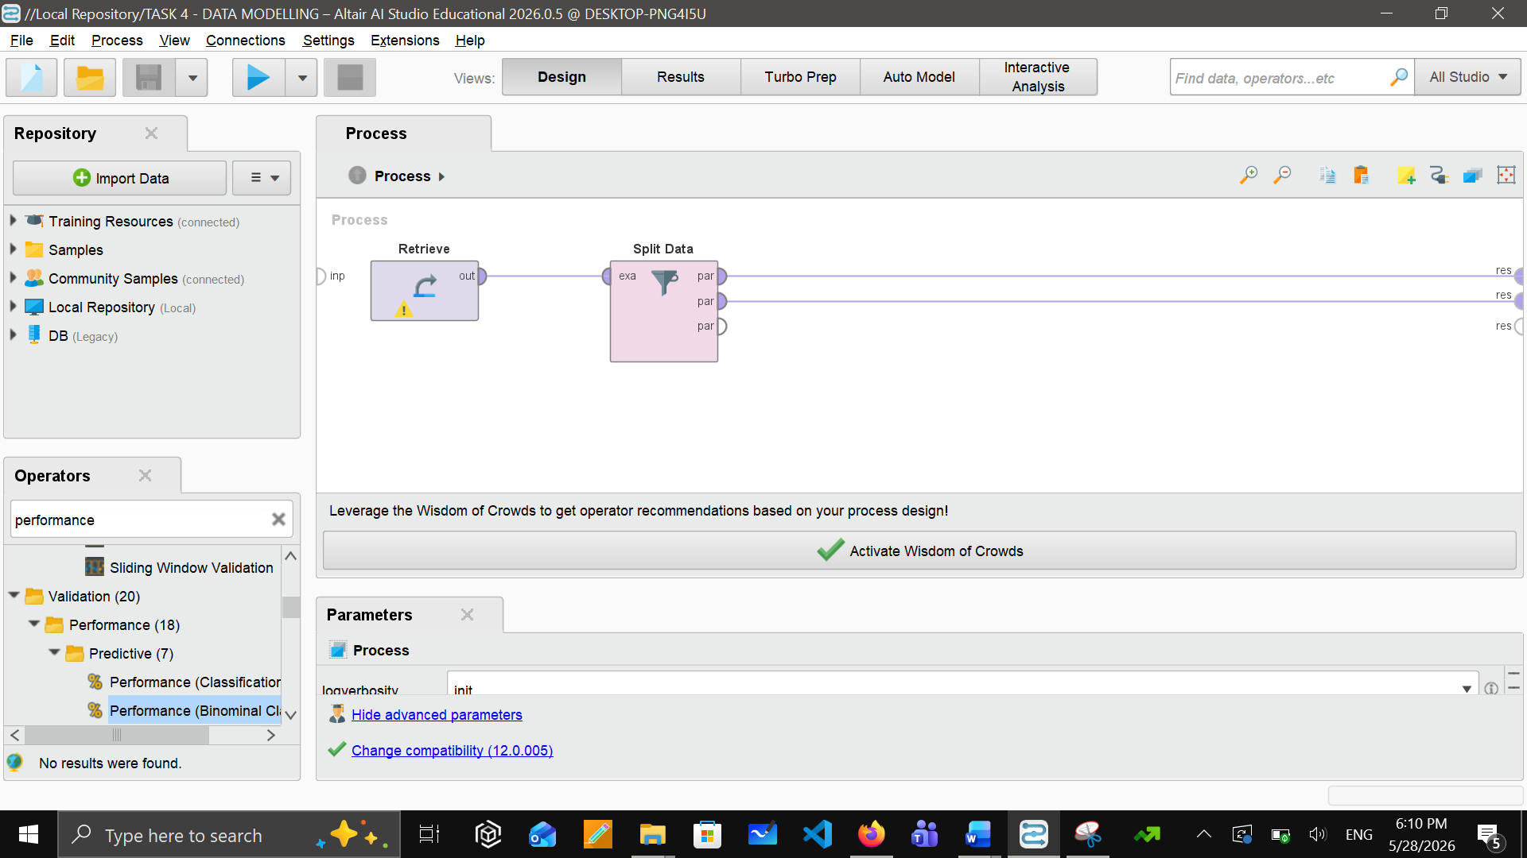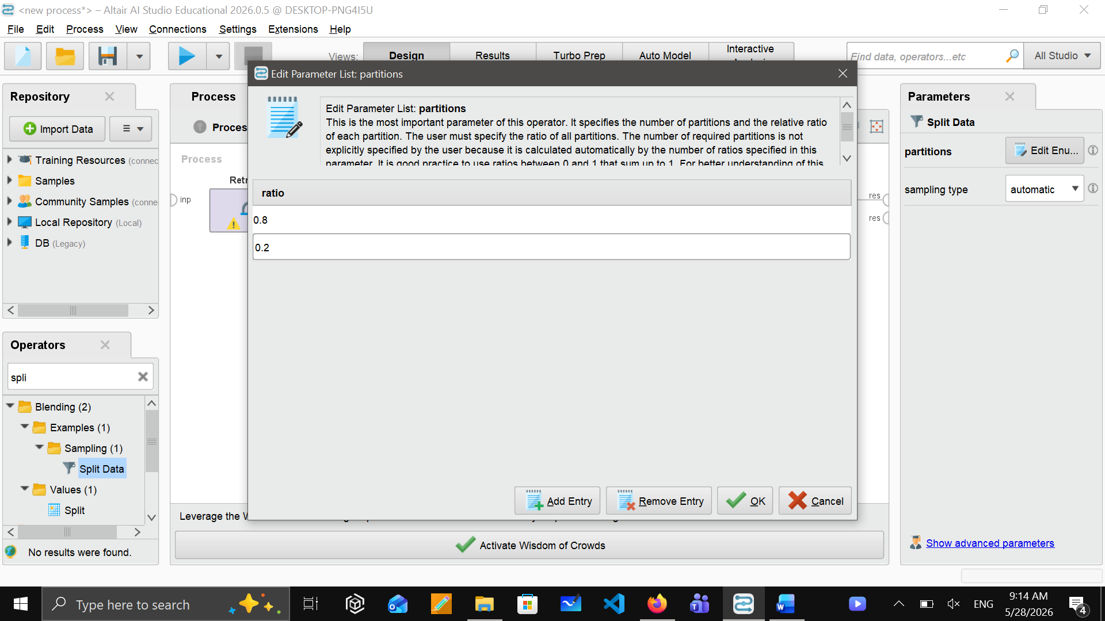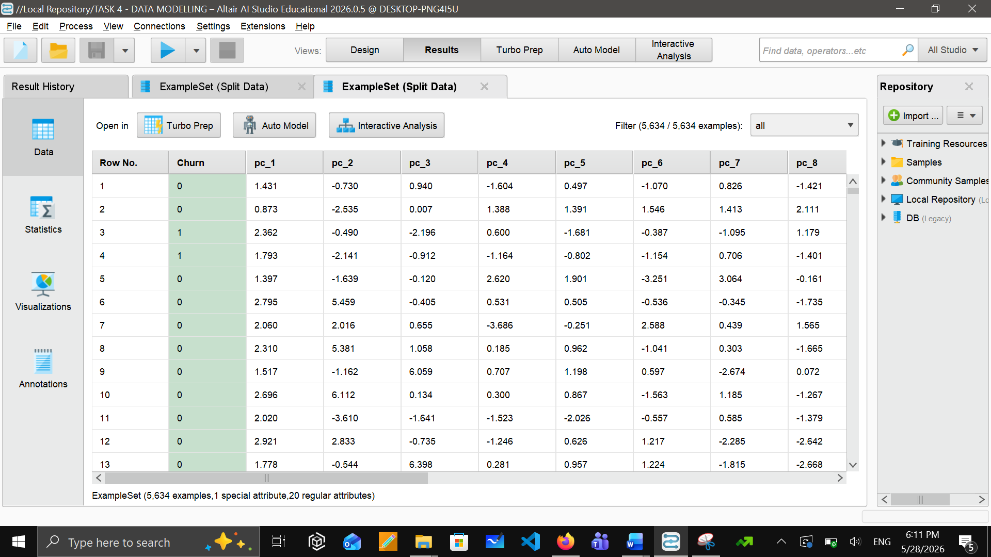

Model 1: Decision Tree Classifier
After completing all pre-processing and data-splitting steps, the Decision Tree model was trained by RapidMiner using the training dataset. Decision tree produces a tree structure where each leaf represents a class prediction.
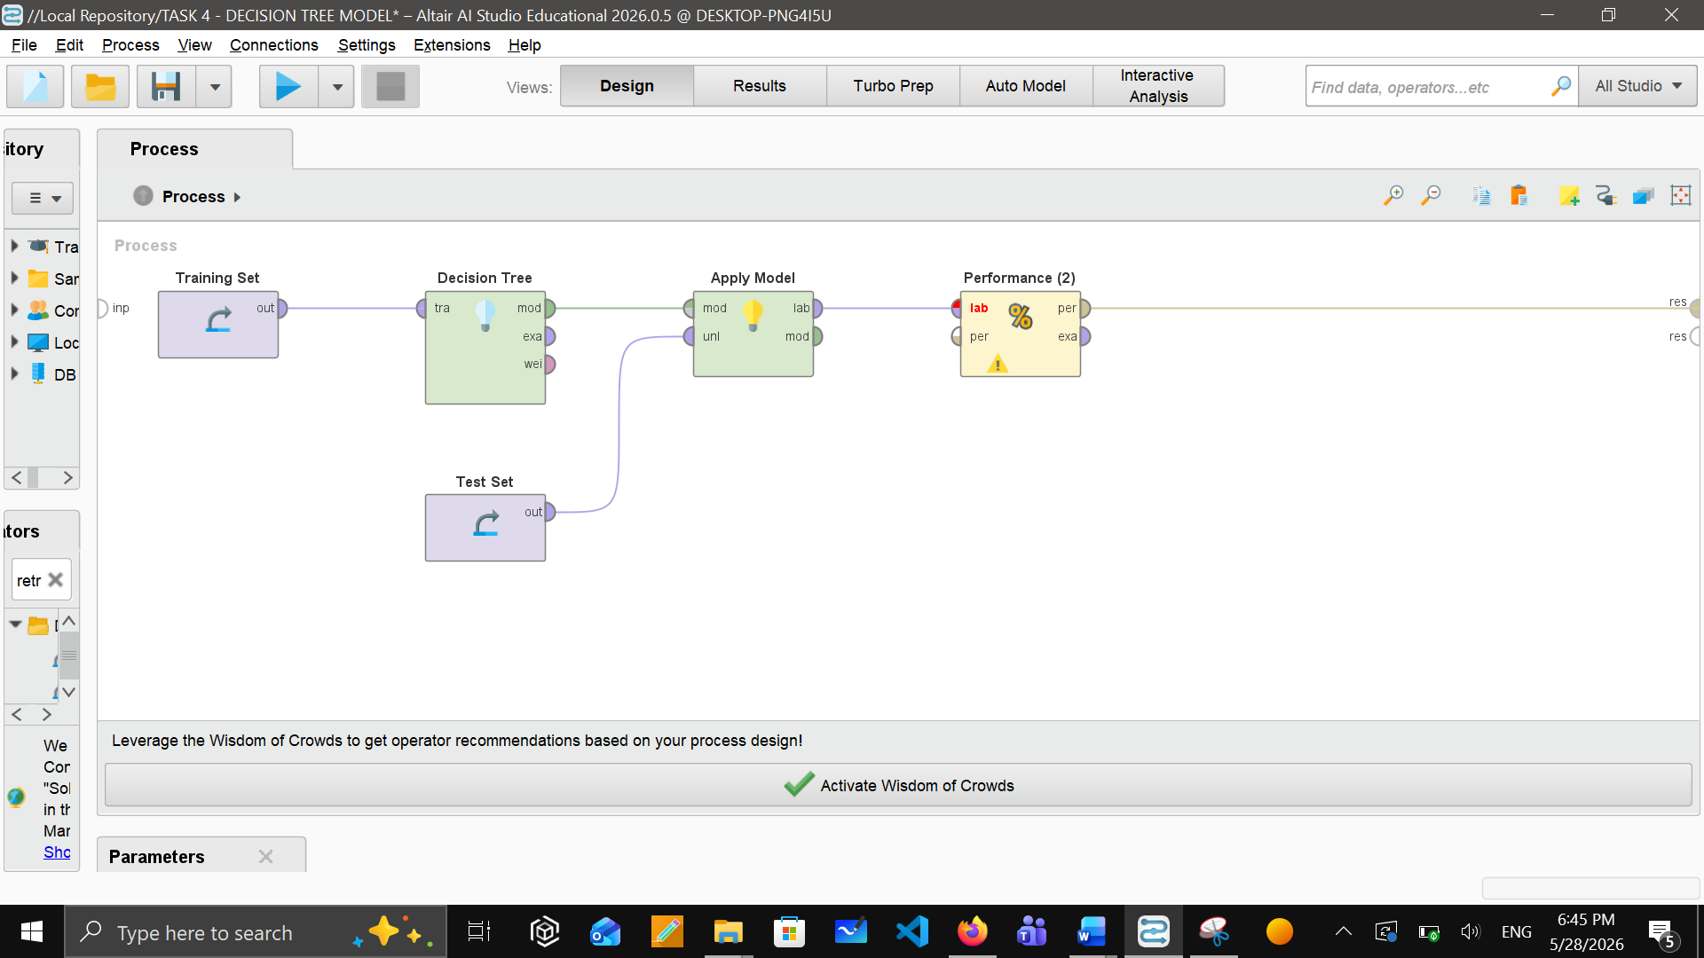

To develop the decision tree, we used the following parameters within the operator:
Maximal depth : 8 (to avoid overfitting from excessive tree depth)
Criterion: Gini Index (efficient for tree classifier)
Minimal Gain: 0.01
Then we connect the decision tree with operators “Apply model” and “Performance”. With the help of performance operator, we get to know the performance of this model along with values and prediction which is as follows:

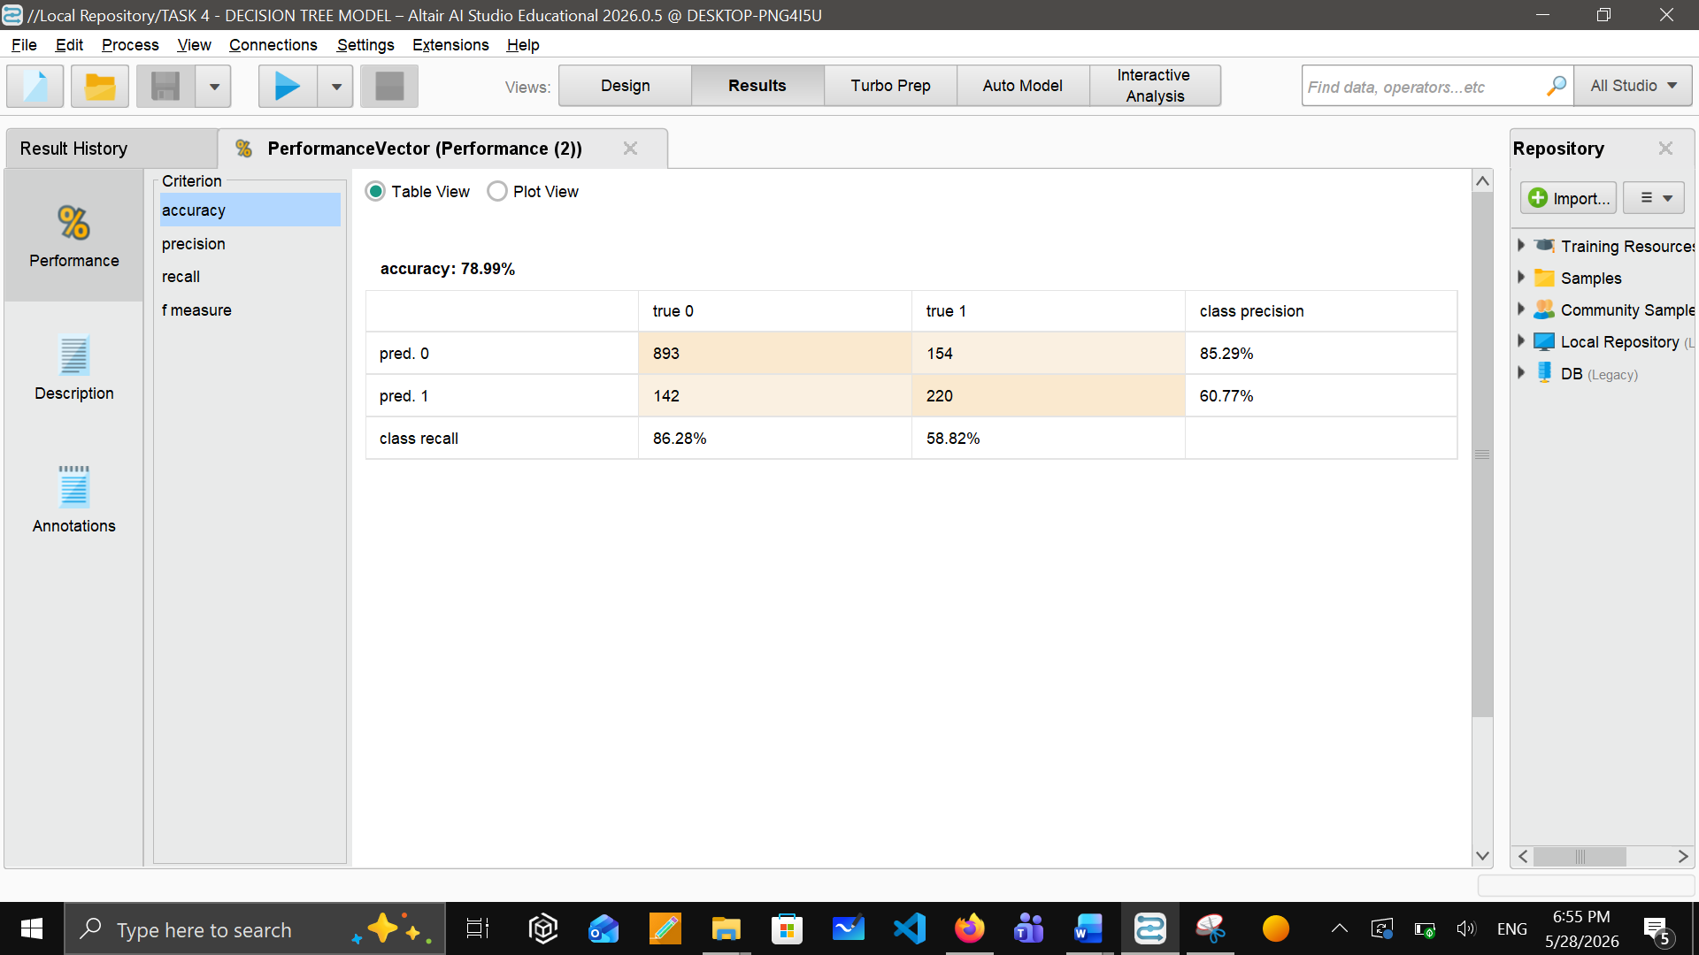

Model 2: Random Forest Classifier
Instead of building one tree, random forest will build many trees and then taking a vote. Each tree is slightly different because each tree is trained at random sample of customers. We choose this model because it gives the best accuracy and it doesn’t overfit like a single decision tree.
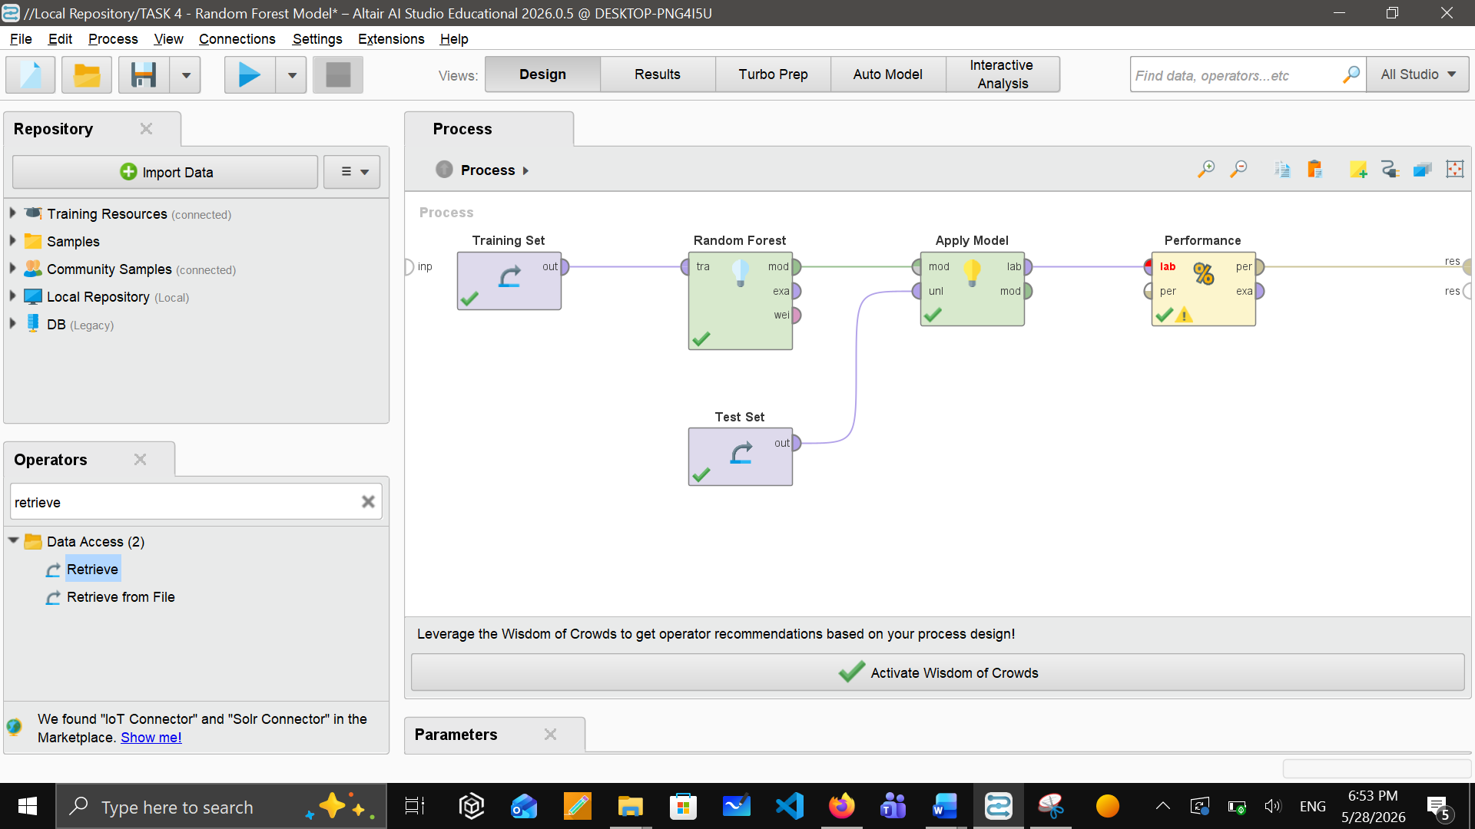

To develop the Random Forest, we used the following parameters within the operator:
- No. of trees: 100 (enough to vote reliably)
- Criterion: Gini index (efficient for tree classifier)
- Max depth: 12 (slightly deeper)
- Voting strategy: Confidence vote (more accurate)
Then again same as the first model, we connect the random forest with operators “Apply model” and “Performance”. Performance of this model is as follows:

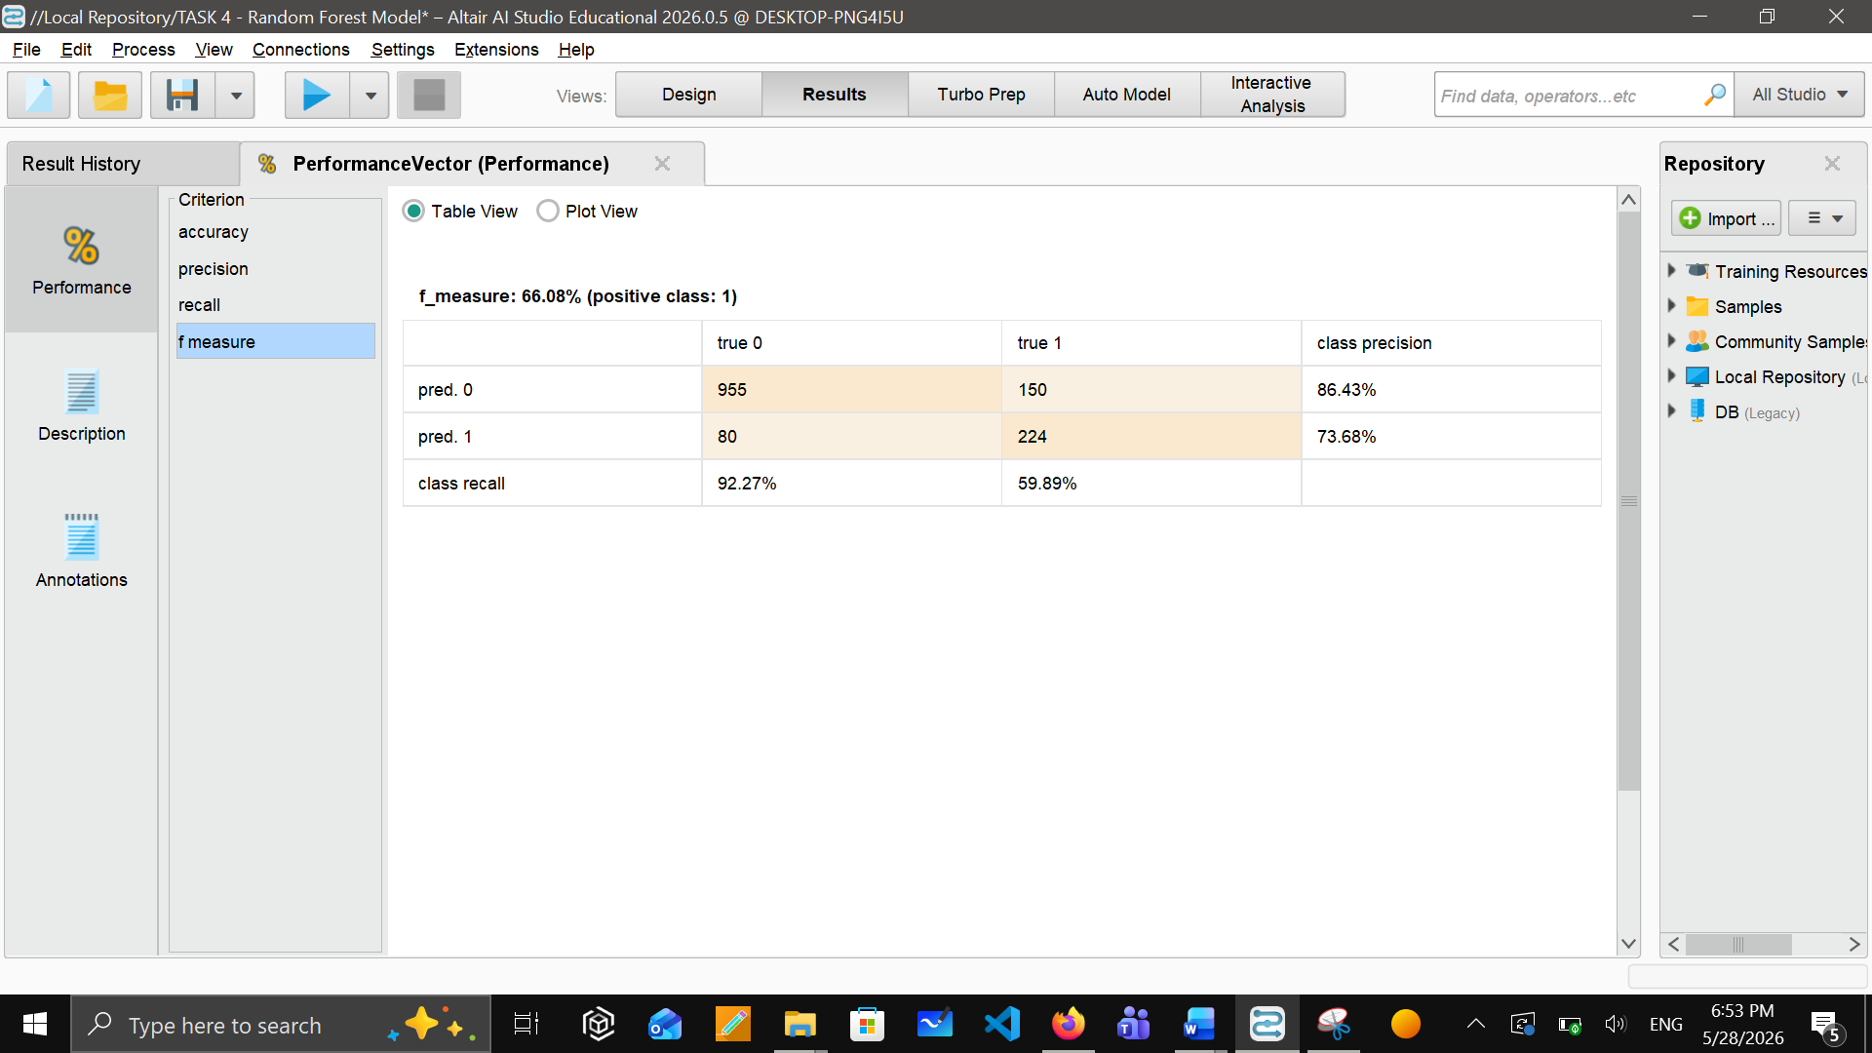

Model 3: Ensemble Voting Classifier
Ensemble voting classifier combines all the models (Decision Tree, Random Forest & Gradient Boosting) and it make them vote on every single customer to average their probability score. We choose this model because it helps to reduce the limit of individual model. Soft voting averages the probabilities from all three models and assign the highest average probability. Gradient Boosting was added as a third classifier because it build trees in a sequence. We added the operator “Vote” and inside that operator, we added all three models. Then again, connected the Vote operator with “apply Model” and “Performance” operators.
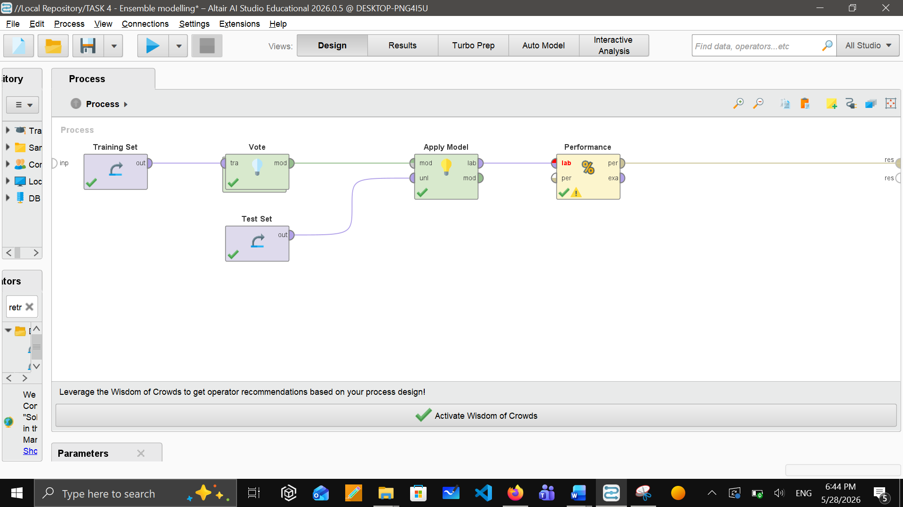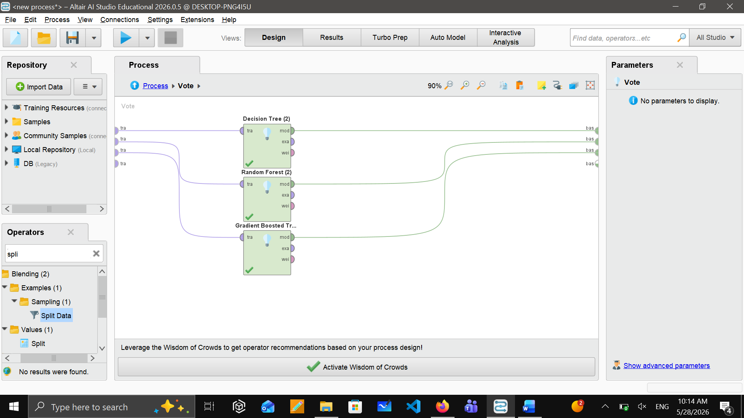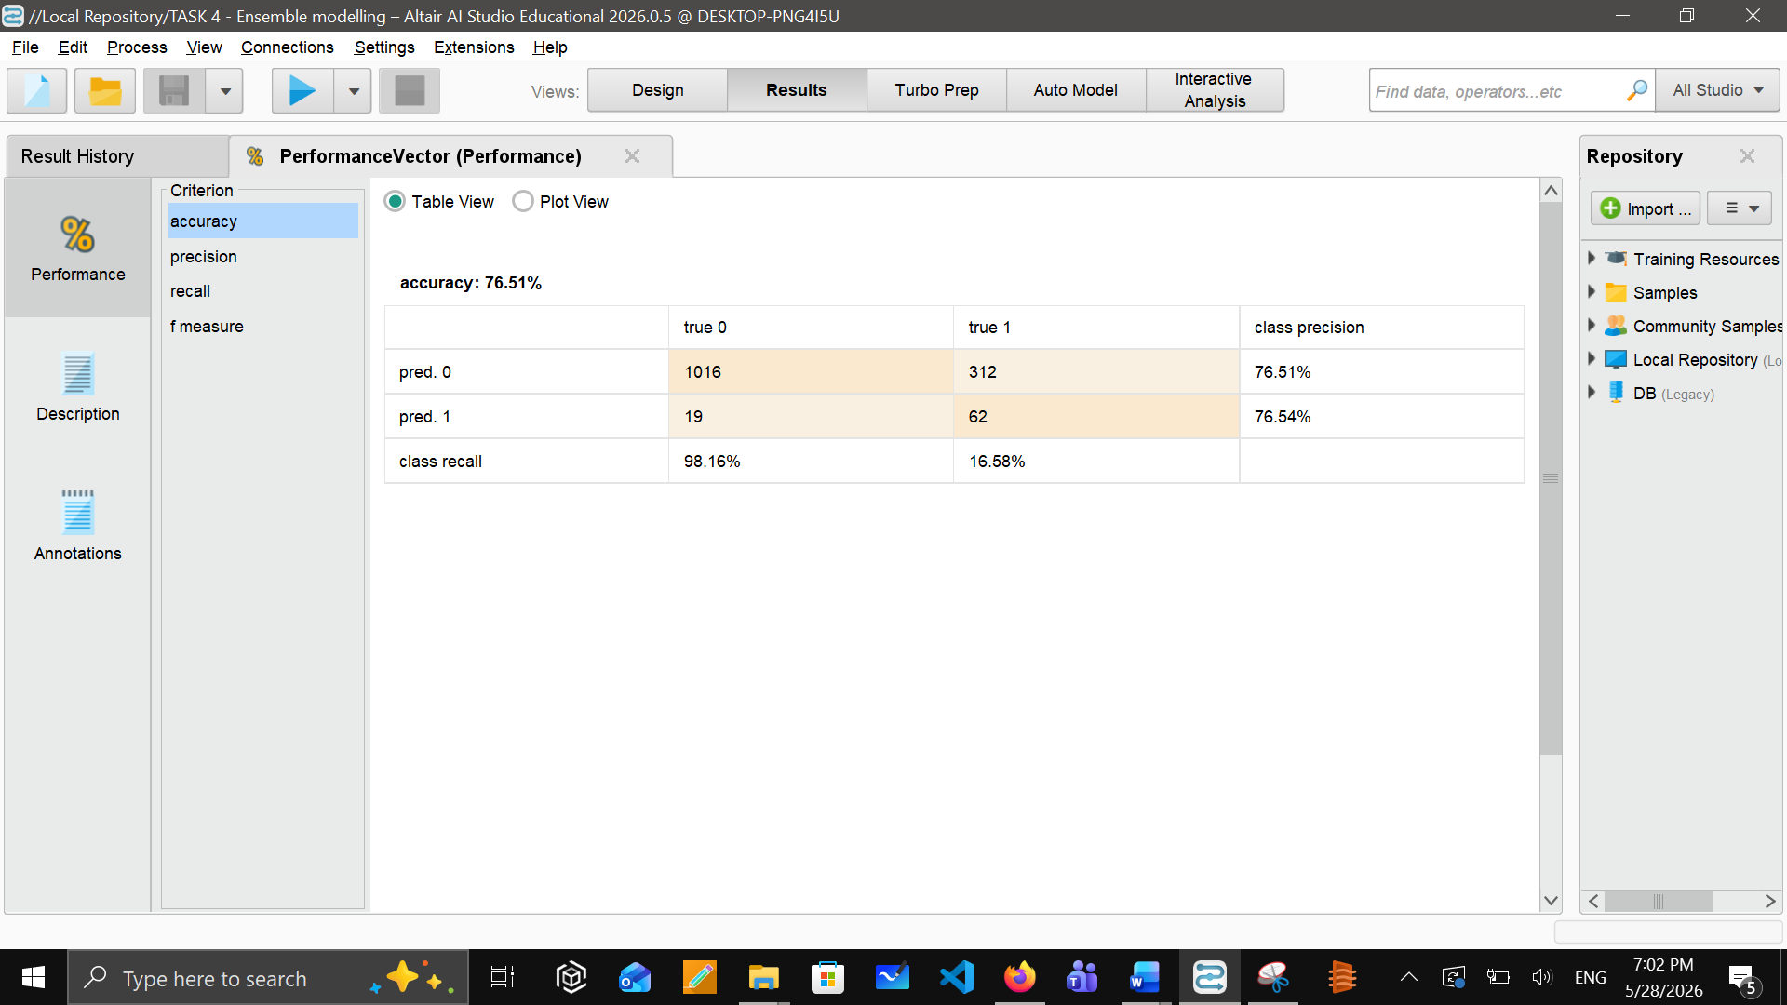

Task 5 - Evaluating Data Mining Models

Metrics Justification
From the performance measurement, we evaluated each model based on various metrics within the performance operator. Metrics we used for our problem are:
- Accuracy
- Precision
- Recall
- F-measure
- Confusion matrix

Based on our project and data, we choose the suitable metrics that I mentioned above. I will explain why did we choose these metrics.

Accuracy: Accuracy metric was added as it helps us to improve the overall data and enables us to make easy comparisons between the three models. It gives us an overall picture of the data which makes it easy for getting correct predictions and straightforward comparison.
Precision: Precision means how many customers are more likely to churn. We selected this for our telecom data because every time model will say customer will churn, company can give offers and discount to them. It is directly linked with their financial cost. High precision means that customers are actually likely to leave or churn. Low precision means Company would waste money on them because they are never going to leave.
Recall: In churn analysis, the worst thing is to lose a customer who is more likely to leave. The company will lose if the model fails to catch that customer. This is the reason we selected recall because it will measure how many customers did the model catch who are about to leave.
F-measure: This is the most important metric specifically for our project. As we have a specific percentage of customers (26.5%) who are about to leave, F-measure provides a balanced performance specifically for the churned group. It basically measures how well it can catch the actual churners.
Confusion Matrix: It is a table that gives us four types of predictions (true positive, true negative, false positive, false negative). It helps to understand the accuracy as well as helps to predict how many actual churners were missing and how many loyal customers are targeted mistakenly.

Model Performance Summary

Now, we will compare all three models based on these performance metrics in the table below:

Model | Accuracy | Precision | Recall | F-Measure
Decision Tree | 78.99% | 60.77% | 58.82% | 59.78%
Random Forest | 83.68% | 73.68% | 59.89% | 66.08%
Ensemble | 76.51% | 76.54% | 16.58% | 27.25%

Model 1 Evaluation – Decision Tree
For the decision tree, there is an accuracy of 78.99% which means it predicted correctly for 79 out 100 customers. Precision value is 60.77% meaning that the more likely churning customers the model predicts, 61 out of 100 actually churned. Recall value is 58.82%, it means that this model caught 59 out of 100 real churners. F-measure of 59.78% shows a moderate balance between recall and precision. Although, decision gives a reasonable performance, it is a weaker model than the random forest model. However, this model is easy to explain and understand. But its low recall value means it is actually missing 41% of actual customers, which is very inaccurate prediction for our churn analysis which can make inefficient and incorrect business decisions.

Model 2 Evaluation – Random Forest
This is the only model which achieves the highest accuracy value of 83.68% meaning it correctly predicted 84 customers out of 100. Its precision value is 73.68% means for every customer it predicted as a churn, 74 out of 100 were the actual churners which is significantly better than the decision tree. Recall value shows that it caught 60 real churners out of 100. Lastly, F measure value is the highest of all. Among all three models, Random Forest is the best performing models by having the best highest metric values, which is reliable and efficient for our project and business. This model is the best because it builds 100 different decision trees and then combine it them all to reduce the mistakes that a single decision tree can make. Moreover, its improvement in precisions shows that the company would not waste much money on customers who are never going to leave. Random forest is the only model among three which is recommended for the deployment.

Model 3 Evaluation – Ensemble (Vote)
This is the only model having the highest precision value, which is 76.54% meaning it predicted 77 actual churners out of 100. But still, it is the weakest model among all because its other metrics are having the lowest values. Its recall value is extremely low as it only caught 17 real churners out of 100. And this results in a low F-measure of 27.25%, which is the weakest of all. Ensemble model has the highest value of precision but very low recall value, it means that when this model predicts the churned customer, it is mostly right but it also loses the large number of actual churners which makes it weak because our primary goal and top priority is to find all the churned customers. So, this model is not suitable for deployment based on our project.

Models Comparison with Bar Chart

Random Forest achieved the highest accuracy (81.26%) and highest F1-Score (58.36%), making it the best performing model among the three models.

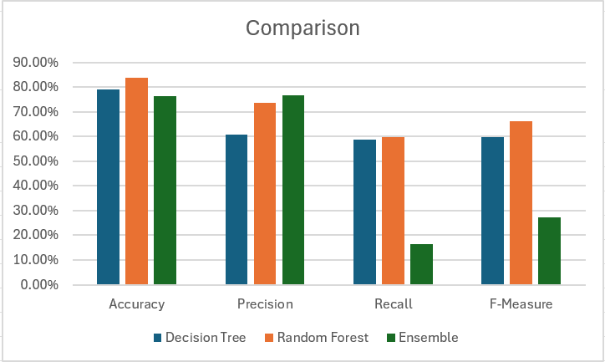

Confusion Matrix
Confusion matrix in all three models shows a strong prediction to identify the customers who will stay. But due to the heavily imbalanced data, there is difficulty in predicting the actually churned customers. Among all three models, random forest performed best because it successfully identified the actually churned customers while maintaining the highest accuracy as well. Random forest is the most reliable model for our targeted customers. Visualization of confusion matrix for all three models are shown below:
Decision Tree
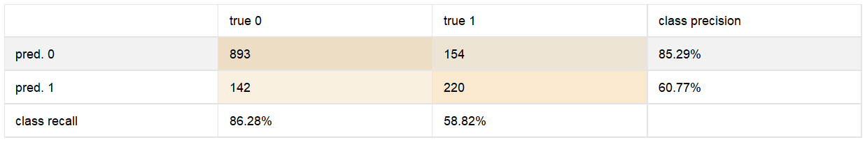
Random Forest
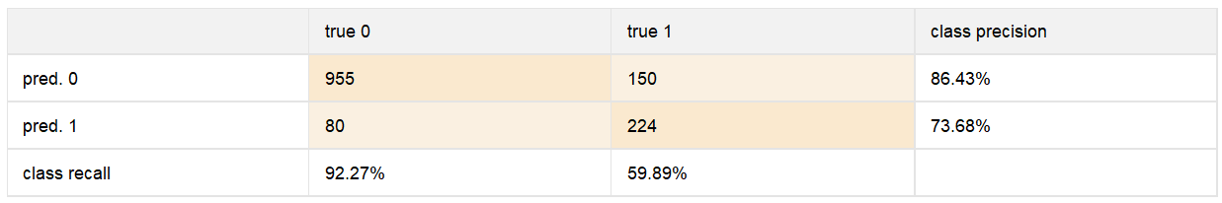
Ensemble
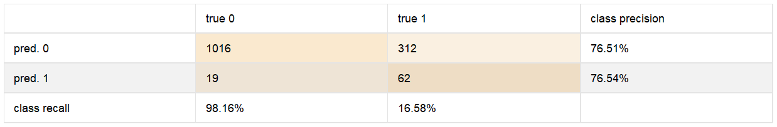

Task 6 – Inferences, Recommendation and Reflection

Final Model Comparison

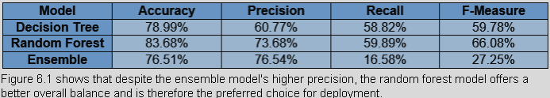

Random Forest is the suggested model. It has the best F1-score (66.08%), the highest accuracy (83.68%), and the best ratio of recall to precision. The Ensemble has the best precision (76.54%), but its recall falls to 16.58%, missing most churners and making it inappropriate for retention. Although it overfits, the Decision Tree is the easiest to understand. Random Forest is the best option for deployment since it maintains low overfitting with only modest interpretability costs.

Key Business Inferences
Month-to-the-month clients tend to cancel often due to lack of long-term commitments. Higher monthly fees contribute to increased churn, negatively impacting customer lifetime value (LTV), and revealing price sensitivity among users. New customers are especially prone to dropping off more quickly than established users. Fiber-optic clients are canceling faster than cable or DSL users, possibly due to perceived value issues or service delivery problems. Furthermore, customers who only use basic services are at greater risk of leaving compared to those who apply for additional product offerings.

Business Recommendations
- Our main recommendation is to deploy the Random Forest model as a real-time system that highlights customers who are more likely to churn every month so that they can contact them before it’s too late.
- Identify the cause of churn. When company notices any churn, immediately contact the customers to ask the reason for churning either through phone call or meeting to gather the detailed information of the churn cause.
- Contract Migration: Offer promotional discounts to motivate high-risk month-to-month users to yearly contracts.
- Pay special attention to the most profitable customers rather than focusing on the customers who are considering leaving.
- Proactive Monitoring: Deploy a predictive churn-alert dashboard using the recommended Random Forest model.
- Quality Auditing: Initiate service and pricing reviews to resolve fiber-optic infrastructure dissatisfaction.
- Communicate with the customers you care. Instead of waiting for them to contact you, take an active role with all the benefits you could provide them.

Scope and Limitations

- Class Imbalance: No advanced techniques like SMOTE were applied for minority churn balancing. During training, these techniques could greatly increase recall value by training model to more churned customers.

- Hyperparameter Optimization: Grid Search was excluded due to computational limits.

- Deployment: No real-time integration for churn scoring.

- Temporal Analysis: Longitudinal analysis was out of scope. Timestamps for each transaction are not included in the dataset. Time series analysis of churn risk customers would result in more predictive insights.

Reflection

- We have learnt a lot of things by working on this project. The most important thing we learn is that data preprocessing takes more time than data modelling. We spend most of our time on data cleaning, handling missing values, and making sure that our data is cleaned and ready to use with any defects before we start doing data modelling. Because we understand that the quality of our final decision is based on how well the data is prepared.
- We also learned one main thing that we cannot judge our model with the accuracy only. Because at the beginning of our project, we were thinking that a model with high accuracy is a good model, but when we saw that in Ensemble modelling, it has a accuracy of 73.46% by predicting every customer as non-churned, we understood why applying different metrics are important.
- Another lesson we learned was understanding the difference between supervised and unsupervised learning. We understand that churn prediction is basically a supervised problem because we already have the data for every customer and we use that data to teach our model.

Improvements
If we had to improve something in our project, first we would do applying techniques to balance our data. Because our dataset has 73.5% non-churned customers and only 26.5% churned customers. Second thing is that we used random forest with 100 trees and if we had more time, we could use cross validation to test hundreds of different combinations and find the best setting for our dataset. Last thing is that we could explore more advanced models which would perform extremely well on our dataset and it could make our accuracy even more higher.

